The 54th Annual Memorial Mass will be held at
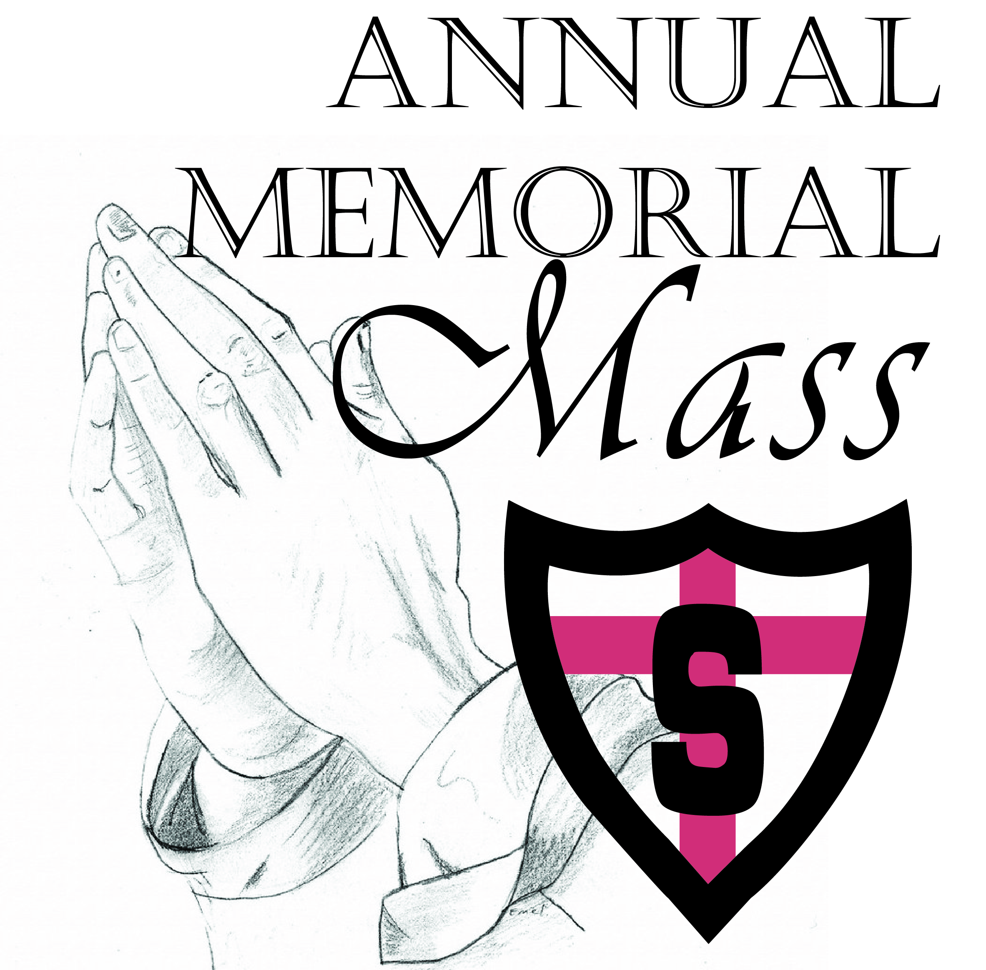
Sts. Anne & Joachim Catholic Church
5202 25th St S – Fargo, ND
Monday, November 2nd at 9:00am

This Mass is said each year to remember and pray for St. John Paul II Catholic Schools and Shanley High School alumni & friends who were memorialized with a gift to the schools during the preceding year. As a memorial donor and/or family member of someone who has been memorialized, we invite you to join us. The Mass exercises our duty and dignity to care for the souls of the faithful departed as part of the JPII Mission “…to teach the total person and foster the following of Christ in an environment inspired by the Gospel Spirit, as taught by the Catholic Church”.

The deceased who will be remembered by name and through a lit candle and prayed for during this year’s Mass:

Lynn Adair ‘66
Patricia Adams
Martha “Marty” Anderson
Tony Appel
Sr. Andrea Arendt
Larry R. Astrup Sr.
Eleanor Axness
Arlene Bailey
James E. Bailey ‘54
Nick Bailey
Rodman Bailey, Sr. ‘51
Luanne (Chap) Baker '69
Robert "Bob" Bakkum
David Barfuss ‘65
Carmella Barker
Nicole Barker
William & Sharon Barker
Jeannette “Janie” Barone
Barbara Bartholomay ‘66
Gordon Bartholomay '54
Jerry Bartholomay
Timothy Joseph Beaton
Julie Ann Bellefeuille ‘77
Swain Benson
Tom Bergeson ‘43
Dr. Duane Berglund
Edward & Augusta Biren
Wayne ’53 & Joanne Blanchard
Jake & Gloria (Wetzstein) Blotsky ‘58
Don Bolgrean ‘71
Bette Bossart
Elizabeth “Betty” (Brown) Bossart ‘55
Gary Boyer
Robert “Bob” & Mary Brown
Michael Raymond Burnett
Diane Bush
Sr. Peggy Byrne
Jim Cameron
Katie (Frost) Carlisle '72
Richard Carlson
Dorothy Chizek
Carol (Bailey) Christensen ‘56
David Christesen ‘66
Sid & Elaine Cichy
Patrick Clark ‘59
Ray & Genevieve Coleman
Br. Michael Collins
J. Michael Collins ‘65
Ken & Pauline Collins
Leo Collins ‘63
Paul Collins ‘69
William Robert Collins, III '64
Liz Anne Conmy
Edwin Cooke
Gene & Joyce Cortese
Clifford ‘38 & Blanche Cossette
Jerome “Jerry” Cossette ‘45
Fr. Alberic Culhane
Ellen Cushing
Dennis Cuypers ‘66
Theresa "Terri" Dahl
Nancy DeCock
Patrick Charles Deutsch '77
Angeline Ding
Morris ’48 & Margaret (Viets ‘48) Doyle
Phyllis C. Drake
Beth (McGarvey) Dronen ‘84
Art & Betty Duchscher
John & Marleane Duginski
Steve Duginski ‘60
Luella Dukart ‘66
Tom & Jackie Dunn
Gabrielle Dunne
Paul Durben ‘66
Dale Duval ‘79
Doran Eaton
Rachel Ellingson '01
Ivan Erickson '55
Micah Erickson '99
Peggy Erickson ‘66
Aloys Feist
Janet Kathryn Feist
Cindy (Nilles) Fellman ‘70
Arden Feser
Mary “Cea” Virginia Fischer ‘66
Cathi Fitzgerald ‘66
Steve Follett ‘66
John Fornes
Timothy John Fornes ‘91
Bob & Joan (Kodelka ‘53) Forstner
Kathy (Cosgriff) Fortney '60
Jeanette Foster '99
L.B. “Jack” & Katie Frost
Thomas Frost '79
Roger Gendreau
Jane Gerdes
Sr. Dominica Gerszewski
Beverly Glessner
Kathy Goeke
Mary Rita "Marita" Goering
Neill & Deborah Goltz
Thomas Goltz ‘72
James “Jim” Lloyd Gompf
Tim “Storm” Gonser ‘65
Steve Gorman ‘42
Paul & Harriet Greving
Gerald "Jerry" Grover '63
Cindy (Cossette) Gunderson ‘73
Dorothea Halverson '57
Gerald & Agnes Hamerlik
Kenneth Hartman
Margaret (Sapa) Hartze '65
Dr. Hugh & Vera Hawn
James Hebert ‘53
Willard ’50 & Mary (Klontz ’50) Hebert
Troy Donald Hegney ‘87
Larry Heier
Jerry & Jeanette Hennen
Josephine “Jody” Hensley
Laura (Martin) Herrick '97
Brian Himmelberger ‘66
Robert Himmelberger
Mary Hnasko ‘66
Rebecca Hollingsworth
Sylvia Holmstrom
Deacon James Hunt
John Charles Jambois
Donald Johnson ‘59
Duane “Butch” Johnson
Jared "J.J." Johnson '93
Marie (Richard) Jones ‘58
Rick & Sue Jordahl
Richard “Dick” Kasper
Joseph O. Keller ‘18
Jack & Delores Kelly
Carter Kleinsasser
Mary Jo Klosterman ‘73
Paul Knosalla ‘72
John Kodelka ‘56
Kari Hamerlik Kolstoe
Sr. Maris Stella Korb '55
David Kosciolek
Monte Kovash
Daniel “Danny” Krein
Thomas Kukowski, Sr.
Katherine Kuppich ‘59
Sidney (Staszko) Kuropchak '70
Leness & Mary Laliberte
Paul Laliberte '66
Eileen LaMont ‘66
Rosemary Lang ‘66
George ’47 & Peggy Manning ‘48 Lavelle
Jim & Mary Lavelle
Loralee Lavelle ‘66
Shirley LaVoi
Jimmy LeDoux ‘74
Randy Lemar ‘84
Mandy Lenhardt ‘94
Rudolph "Rudy" Thomas Lenhardt
Ralph Lenzmeier
Earl Lessard
Virginia "Ginny" (Mason) Lynch '42
Tony & Norma Magelky
Roger Maris ‘52
John Mark
Lois Massa
Sr. Gertrude Massine '61
Thomas Matchie
Jane Marie Mathew
Beatrice Bertha Mattern
James Maurer ‘66
Peggy McDonald ‘66
Earl & Adel McDonnell
Ray ’45 & Nancy (Nilles ’45) McLaughlin
Lowell “Pat” McManus
Patrick McManus '91
Catherine (Stevens) McMullen ‘47
McKenzie Marie Mehlisch
Dennis Meier
Raymond Meier
Victor Meier
Leo Joseph Meyer
Robert Meyer ‘79
Don & Ruth Mickelson
Rick Mickelson ‘82
Carol Miller ‘66
Michelle Miller
Harry Moe
Gene Monteith
Walter Montplaisir ‘53
John & Betty Moraghan
Phyllis Morehead
Jeffrey W. Muhle
Patricia Kay Muldoon
Andrew Nelson ‘03
Randy Nelson
Patricia “Patty” Neuharth
Kyle Newman
Bill ’47 & Betty Nilles
Ralph Nilles ‘66
Anthony “Tony” Nistler ‘76
Steve & Mary Lou Nistler
Gretchen Margaret Noah
John & Mary Noah
Chuck Noesen
Ronald & Laura Noesen
Teresa Marie Nord ‘88
Ken Novak ‘66
Paul “Earl” Obermiller ‘50
Gerard & Mary Ellen Obert
Chandler O'Leary '99
Bud & Betty Olson
Dennis Olson
Rita Pearson
Mary (Samels) Pease '50
Michael B. Pflugrath Jr.
Pete Pianka ‘65
Gregory Pratschner ‘66
Duane Quaschnick
Gary Riedman
Jacob Riedman
Lois Riedman
Raphael "Ray" Riedman
Lavetta Ringuette ‘66
Gerald Rivard
Gregory Roberts
Eleanora Roder
Robert Rowell ‘71
Irvin Devitt Rustad
Randall R. Rustad ‘68
Rita Ruud ‘70
Rose Ruud
Shirley Ruud
Kirby Sandvik
Joanne Sandy
Larry Sattler
Bonnie Sauvageau ‘66
Loretta (Dullea) Sauvageau '70
Lloyd Albert Schmidt
Edward Schmitz
Judith (Larson) Schmitz '60
Raymond & Rosemary Schneider
Robert Schoener ‘47
John Schons ‘55
Tim Schons ‘72
Rodney "Chuck" Schott '80
Rodney & Evelyn Schott
Gary Schulz ‘60
Mary Jean Schulz
Kevin Schwab
Thomas Schwebach
Catherine (Rutten) Schwinden '68
John Dennis Scott ‘69
Peter Seeba
Patricia (Rush) Setter '51
Edward Shorma
George Sinner
Charles "Chuck" Sjostrom
Faith (Hall) Smith ‘61
Thomas Charles Sornsin, Jr. '66
Evelyn (Ukestad) Soukup ‘48
Joseph Spier ‘66
Rachel (Torgerson) Steckling '09
Fr. Leo Stelten
Kathleen Strunc
Kathy Swann
Bill & Jeane Sweeney
Ella Sky Sweeney '20
Larry ‘50 & Peggy (Murphy) Sweeney ‘50
Paul Sweeney ‘82
Hildegarde Taylor
Adam & Johanna Thiel
Frank Thomas
Mary Lou Thoreson
Danial Tierney ‘66
Jeffrey Dean Tilton '86
Douglas Toliver ‘70
Joanie Tool
Rita Traynor
Susan Turner ‘66
Bernard John Urlaub
Patricia Vacek
Elaine (Barth) VanDeVoorde ‘80
Msgr. Jeffrey Wald
Sr. Jane Michael Walker ‘39
Marty & Verna Walsh
Jean Wanner
Tyler James Ward
Roy Wasche ‘70
Cheryl (Birk) Wegner '70
Charles "Chuck" Wehage '56
Mary (LaBore) Weiler '61
Nancy Weinmann ‘66
Tom Westerholm ‘71
Cheryl Jean Wiebe
Judy Wilk ‘66
Laura Williams-Jaffe '71
Jay Wold
Jim ’53 & Jean (Williams ’53) Wold
Kathleen Wolf ‘66
Donald R. Wood ‘47
David John Wosick
John Wren
James "Jim" Thomas Young
Denise (Fitzgerald) Yunker ‘65

