APGO Health Systems Science Session 2 Facilitator Guide

Tara N. Cohen, PhD

Objective
The objective of this session is to prepare learners to use a Systems Thinking and Human Factors approach to identify systemic failures and develop and rank potential interventions. The learners will be guided through the Systems Thinking and Human Factors methodology, Human Factors Intervention Matrix (HFIX), and FACES ranking to achieve these goals.

Overview
This session is made up of two videos and three activities. The Systems Thinking and Human Factors animated video will form the backbone of the session and will be intermittently paused and resumed to allow (1) the ectopic event analysis scenario video and (2) each of the worksheets.

Materials Needed
- Monitor/projector to play videos
- Videos
  - “Session 2 - (01) Systems Thinking Human Factors Didactics Video.mp4”
  - “Session 2 - (02) Ectopic Pregnancy Event Analysis Scenario.mov”
- For facilitator
  - Facilitator guide: “Session 2 - (03) Facilitator Guide”
- For each participant
  - Handouts and Worksheets: “Session 2 - (04) Student Handouts and Worksheets”

Lesson Plan

Action | Time | Related Handouts
Video – Systems thinking Human Factors Didactics | 1 minute
Video – Ectopic Pregnancy Event Analysis Scenario | 6 minutes
Video segment  - Systems Thinking | 5-8 minutes
Activity 1: Systems Thinking | 10 minutes | Activity 1 Handout: Systems Thinking  Activity 1 Worksheet: Systems Thinking
Video segment  - HFIX | 5-8 minutes
Activity 2: HFIX | 12 minutes | Activity 2 Worksheet: HFIX
Video segment  - FACES | 5-8 minutes
Activity 3: FACES | 8 minutes | Activity 3 Handout: FACES  Activity 3 Worksheet: FACES
*See Event Analysis and Solution Development Process Map at the end of this document.

Lesson Plan (detailed)

Video – Systems Thinking and Human Factors
- Start by playing the systems thinking and human factors video. This will introduce the students to the topic.
- At 0:40, pause the video.
- Switch to “Session 2 - (02) Ectopic Pregnancy Event Analysis Scenario.mov” video.

Video – Ectopic Pregnancy Event Analysis
- Play the video.
Here, students will see first-hand what an event analysis meeting looks like. The Joint Commission mandates that a root cause analysis (RCA) meeting be held whenever a “sentinel event" occurs. In these meetings the group takes a systemic perspective to evaluate the event that occurred with the goal of developing solutions that will prevent the occurrence of a similar event in the future.
- Major players in the video are the Chief Medical Officer, Nurse Facilitator, and Physicians involved with the incident (Chief resident, intern, Gynecology attending, Emergency Department attending).
- The video will complete on its own; switch back to the “Session 2 - (01) Systems Thinking Human Factors Didactics Video.mp4”

Video segment: Systems Thinking
- In the original Systems Thinking and Human Factors Video, start again at 0:45.
Now students will learn about systems thinking. The video will discuss James Reason’s Swiss Cheese Model of Accident causation. This model contends that any healthcare organization has four layers or defenses against threats to patient safety. Each layer is depicted as a piece of swiss cheese in which the holes represent potential weaknesses in individual parts of the system.
- Students will learn about each of the four layers/barriers of defense discussed in Reason’s model: Unsafe Acts, Preconditions for Unsafe Acts, Supervisory Factors, and Organizational Influences. By understanding the various layers of defenses and the potential failures that can occur at each layer, students will be better prepared to use systems thinking to identify possible threats to system safety (refer to Activity 1 Handout: Systems thinking for examples)
  - The Unsafe Acts tier consists of active failures or issues that directly result in an accident or incident. Unsafe acts consist of both errors, or honest mistakes and violations, or willful disregards for the rules and regulations.
  - The preconditions for unsafe acts tier consists of latent failures or issues that contribute to an accident or incident. Preconditions for unsafe acts can consist of individual factors, team factors, and situational factors.
  - Next is the Supervisory Factors tier. This tier also consists of latent failures associated with supervision in a given organization. Failures at this tier consist of poor supervision, planned inappropriate operations, failure to correct known problems and supervisory violations.
  - Finally, the organizational factors tier is reserved to latent failures related to an organizations culture, resource management and operational process.

Activity 1: Systems Thinking
- Within their packet, the first two pages should be Make sure that each student is provided with Activity 1 Handout: Systems Thinking and Activity 1 Worksheet: Systems Thinking.
- Give the students 4-5 minutes to complete the Activity 1 Worksheet.
Students are to identify two contributing factor statements (statements from the narrative of events that may have contributed to the hazard discussed in the Event Analysis meeting video) for each of the four overarching layers from James Reason’s Swiss Cheese Model.
- Group discussion (4-5 minutes). Ask the students to provide and discuss one example from each of the layers to discuss as a group.

Video segment: HFIX
- Resume the video (approximately 4:25).
In this part of the video, students learn about the Human Factors Intervention Matrix (HFIX), a framework used to assist individuals in using a human factors/system thinking approach for developing interventions at all levels of a given system to reduce the likelihood of repeat adverse events.
- Students will learn to consider fixes for all five components of a system discussed: (1) physical environment, (2) task, (3) tools and technology, (4) individuals and teams, and (5) supervisory/organization

Activity 2: HFIX
- Make sure that each student is provided with Activity 2 Worksheet: HFIX.
- The purpose of this activity is to use systems thinking to focus on developing solutions for all levels of a system. Instruct students to complete the worksheet by choosing three systemic vulnerabilities (identified during activity 1) and identifying solutions for each of the five HFIX categories discussed.
- Refer to the table at the top of the worksheet to guide potential to guide potential solution generation in each of the five HFIX categories.

Video: FACES
- Resume the video (approximately 9:25) and complete it.
Students will learn about a last human factors tool that can be used to help rank interventions to determine which ones are more likely to be successful.
- In this video students learn about five important factors for estimating the potential success of an intervention. We discuss Feasibility, Acceptability, Cost/Benefit, Effectiveness, and Sustainability.
- Refer to Activity 3 Handout: FACES for an in-depth explanation of how to rank each proposed intervention.

Activity 3: FACES
- Make sure that each student is provided with Activity 3 Handout: FACES and Activity 3 Worksheet: FACES.
- Instruct students to identify 2-3 potential solutions (originally listed during Activity 2, using Activity 2 worksheet: HFIX). For each potential solution, rank the feasibility, acceptability, cost/benefit, effectiveness, and sustainability on a scale from 1 to 5 and sum the total score.
- When they are done ranking each intervention, ask students to volunteer to describe their highest and lowest scored interventions.

For any questions, please feel free to contact me at melissaspringwong@gmail.com; thank you!

Event Analysis and Solution Development Process Map

Systems Thinking

HFIX

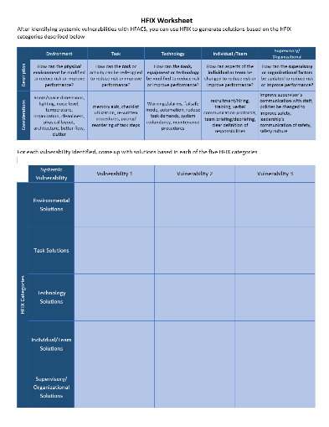

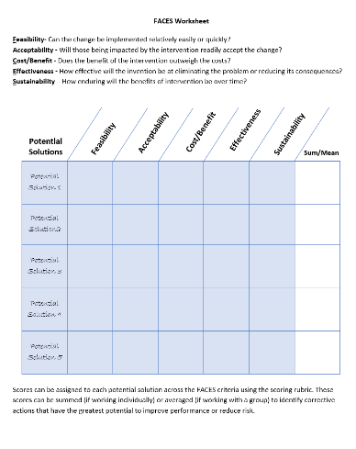

FACES

