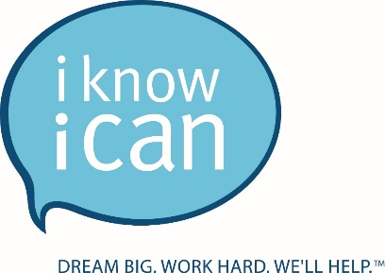
COVID-19 Statement

As a leadership team we are closely monitoring COVID-19 situation and as new information is released, we are taking extra precautions to make sure that we are prepared for the impact this will have on our organization and staff. Our staff is our most valuable asset and we want to ensure you that we are staying on top of new information as it comes in so that we can make immediate decisions to keep everyone healthy.
Here are the steps that we have taken thus far to protect our employees:
- Provide disinfecting and cleaning materials to all staff
- Doubled the number of weekly cleanings within the administrative offices
- Wiping down commonly used surfaces throughout the work day
- Suspend business travel & conference attendance
- Suspend evening programming involving groups of families and students
- Asking employees to stay home if they or someone in their home is sick
- Requiring a 5-day quarantine period for any employee who has recently traveled in large groups or been in environments of confirmed COVID-19 cases
- Provide employees with CDC recommendations on suggested hygiene practices

Here are the steps that you can take to protect yourself:

The best defense against contracting COVID-19 or other illnesses like influenza is to follow good hygiene. Wash your hands often with soap and water for at least 20 seconds. Wash your hands or use hand sanitizer before and after touching your face, mouth or eyes. Other ways to reduce exposure or transmission include:
- Avoid close contact with people who are sick
- Avoid touching your eyes, nose and mouth
- Avoid shaking hands with others
- Stay home when you are sick
- Make sure your work areas and hard surfaces are cleaned with common cleaning agents
- Cover your cough or sneeze in a tissue and throw the tissue away
- If you have a fever, cough and difficulty breathing seek medical care early and share previous travel history with your health care provider
- Make sure your emergency contact information is up to date

Work From Home Environment

Beginning Monday, March 17th and continuing until further notice, we will implement work from home guidelines that prudently reduce building occupancy to support increased social distancing, while still providing us the ability to respond to our students and family’s needs.
Colleagues working from home will have the flexibility to also care for minor, dependent children while still meeting their work obligations during this time.

Traveling for business or pleasure

Due to the dynamic nature of the COVID-19 outbreak, all employee business travel will be suspended as of March 12, 2020. This includes, but is not limited to, any conferences or large gatherings such as Blueprint and FAFSA workshops. If you have any personal travel plans scheduled, we are not asking that you cancel any prior plans at this time. If you do decide to travel, via any method of transportation, to a location that is considered a COVID-19 high risk area, you will be required to remain home for 14 days from the date of your return. If the 14 days that you are required to be quarantined extends beyond the work from home environment, you will be required to use any sick, personal or vacation time that you have accrued. You may also take the time without pay if you do not have enough hours to cover the required quarantine period. This is applicable to any travel that occurs during the COVID-19 Pandemic.
This is a quickly evolving situation and we are committed to keeping you informed. We strive to make decisions that balance the safety of our employees along with our commitments to our students and families. We encourage you to check the Center for Disease Control & World Health Organization for current updates and FAQs relating to COVID-19. Furthermore, as we continue to learn more from the Governor’s office and our partner districts, we will update you via the weekly mandatory conference calls.
Thank you,

Katina Fullen

