

Hazardous Waste Manual Daytona
Environmental, Health & Safety

Contents
I. Overview 2
II. Hazardous Waste Determination 3
Definitions 3
How to Make a Hazardous Waste Determination: 3
A. Characteristics of Hazardous Wastes 4
B. Listed Hazardous Wastes 5
C. Non-Regulated Waste/Non-Hazardous Waste 5
D. Universal Wastes 6
E. Waste Pharmaceuticals 6
III. Labeling Requirements 7
Directions for Labeling 7
Waste Label Examples 8
IV. Accumulation Requirements 10
V. Waste Segregation 11
VI. Container Compatibility 12
VII. Hazardous Waste Pickup Procedure 14
VIII. Landfill/Drain Waste Disposal 15
IX. Spill Cleanup Procedure 21
X. Special Wastes 22
Appendix A: Wastes Excluded from Solid Waste Regulation 24
Appendix B: TOXICITY CHARACTERISTICS 28
Appendix C: Pharmaceutical Wastes 29
EPA Regulated Chemicals with Medicinal Uses 30
Appendix D: Hazardous Waste Determination Form 31

Overview

The Federal Resource Conservation and Recovery Act (RCRA) established the framework for hazardous waste regulation in 1976. RCRA was enacted by Congress to protect human health and the environment from improper management of hazardous waste. RCRA introduced the concept that the generator of a waste is responsible for proper waste management from "cradle-to-grave" (i.e. from induction to complete destruction/permanent storage). RCRA regulations are found in 40 CFR Parts 260-279.

The EPA Administrator signed the final Hazardous Waste Generator Improvements Rule on October 28, 2016 and it was published in the Federal Register (FR) on November 28, 2016. This new rule updates the 1976 rules and has some changes that affect how ERAU must handle our hazardous waste.

At Embry-Riddle Aeronautical University (ERAU), all hazardous waste collection and temporary storage are managed by the waste generating laboratory or department. Chemicals are not allowed to be disposed of in drains, in the trash or by evaporation. All hazardous waste is required to be held in the generating location until the container is full (defined as a satellite accumulation area). Once a container is full (10% head room in container) notify the EH&S department to schedule a pick-up.

There are specific regulatory requirements for individuals who generate and accumulate hazardous waste: minimize and recycle, properly label and identify, and properly contain and dispose of hazardous waste. The purpose of this document is to assist labs and departments with RCRA regulatory compliance. Every lab and department on campus is subject to unannounced inspections by:
- Florida
  - Federal Environmental Protection Agency (EPA), Florida Department of Environmental Protection (DEP), Volusia County Environmental Management (VCEM), and EH&S.
- Arizona
  - Federal Environmental Protection Agency (EPA), Arizona Department of Environmental Quality (ADEQ), Campus Safety, and EH&S

Lack of compliance can result in citations, fines and possibly criminal charges.

The regulatory requirements covered in this document include:
- Hazardous waste determination
- Proper labeling of a hazardous waste
- Requirements for accumulation and disposal of hazardous waste

Hazardous Waste Determination

Definitions

Solid waste is defined as any garbage, refuse, sludge and other discarded material, including solid, liquid, semisolid, or contained gaseous material resulting from industrial, commercial, mining, agricultural operations, and community activities. A material is considered discarded if it is abandoned, inherently waste-like, or recycled in certain ways.
- Abandoned: The term abandoned means thrown away. A material is abandoned if it is disposed of, burned, incinerated, or sham recycled.
- Inherently Waste-Like: Some materials pose such a threat to human health and the environment that they are always considered solid wastes; these materials are considered to be inherently waste-like. Examples of inherently waste-like materials include certain dioxin-containing wastes.
- Recycled in Certain Ways: A material is recycled if it is used or reused (e.g., as an ingredient in a process), reclaimed, or used in certain ways (used in or on the land in a manner constituting disposal, burned for energy recovery, or accumulated speculatively). Specific exclusions to the definition of solid waste are listed in the Code of Federal Regulations (CFR) at 40 CFR section 261.4(a). Many of these exclusion are related to recycling.

Discarded military munitions are all ammunition products and components produced for or used by the U.S. Department of Defense (DOD) or U.S. Armed Services for national defense and security. Unused or defective military munitions are solid wastes when:
  - abandoned (i.e., disposed of, burned, incinerated) or treated prior to disposal;
  - rendered nonrecyclable or nonusable through deterioration; or
  - declared a waste by an authorized military official.
  - Used (i.e., fired or detonated) munitions may also be solid wastes if collected for storage, recycling, treatment, or disposal.

A hazardous waste determination must be made at the point of generation by the waste generator prior to any dilution or other alteration of the waste occurs. The hazardous waste generator is the person who creates/produces hazardous waste and is responsible for making the hazardous waste determination, correctly storing the waste and inspecting the waste.

Some wastes are listed as excluded hazardous waste, meaning they are excluded from the definition of solid waste. These materials are excluded for a variety of reasons, including public policy, economic impacts, regulation by other laws, lack of data, or impracticability of regulating the waste. The decision to exclude the following materials from the solid waste definition is a result of either Congressional action (embodied in the statute) or an EPA rulemaking. See Appendix A

How to Make a Hazardous Waste Determination:

- The hazardous waste determination for each solid waste must be made at the point of waste generation before any dilution, mixing, or other alteration of the waste occurs.
- Identify all feedstocks and chemicals used to produce product or service (or conduct experiments)
- Identify products, and secondary materials derived from production
  - Identify points of generation for each of these secondary materials
  - Identify which secondary materials are solid wastes
  - List composition of wastes such as:
    - Acetone 90%, Metal Iron Filings 1-5%, Water 1-5%
- Make a hazardous waste determination for each solid waste
  - A material is a hazardous waste if it meets any singular Characteristic or Listed Waste.
  - A material may have multiple characteristics or listings.
  - Acceptable generator knowledge can be used to determine if it is a listed waste
- Submit to EHS a copy of all applicable Safety Data Sheets and the Waste Determination Form in Appendix D, and posted on the ERNIE EHS page.
- The above information is sent to the hazardous waste contractor to make a Waste Profile.
  - Example: Acetone 90%, Metal Iron Filings 1-5%, Water 1-5%
- Check your chemicals in the Hazardous Materials Table posted on the ERNIE EHS page.
- Identify your chemicals in the Waste Codes document posted on the ERNIE EHS page.

A. Characteristics of Hazardous Wastes

A waste is hazardous if it exhibits any of the four characteristics of a hazardous waste. The following are the four characteristics and a few examples of common wastes at ERAU:

- Ignitable D001
- Flammable Liquids- Flashpoint <140° F
  - Examples: Alcohols, Benzene, Toluene, Xylene, Acetonitrile
- Oxidizers
  - Examples: Nitrates, Perchlorates, Bromates, Permanganates, Peroxides, Periodates
- Organic Peroxides
  - Examples: Benzoyl Peroxide, Cumene Hydroperoxide, Methyl Ethyl Ketone Peroxide
- Corrosive D002
  - A material with pH ≤ 2 or pH ≥12.5 or other materials capable of corroding steel at a rate of > 6.35 mm (.25 inches)/year at a test temperature of 55° C (131°F).
    - Inorganic Acids
    - Examples: Hydrochloric Acid, Sulfuric Acid, Nitric Acid, Perchloric Acid, Phosphoric Acid
  - Organic Acids
    - Examples: Formic Acid, Lactic Acid, Acetic Acid
  - Bases
    - Examples: Hydroxide solutions, Amines
- Reactive D003
  - Materials that can react violently with water, create toxic and/or flammable gases when mixed with water, ignite or react upon exposure to air or are capable of detonation at standard temperature and pressure.
    - Sulfides and Cyanides
    - Peroxide Formers
    - Alkali Metals - Sodium, Potassium, Lithium
    - Dinitro and Trinitro Compounds - Picric Acid
    - Carbonyl Compounds
    - Isocyanates
    - Perchlorate Crystal Formers - Perchloric Acid

- Toxic D004-D043
  - A selected group of eight (8) heavy metals, ten (10) pesticides, and twenty-two (22) organic chemicals are classified as hazardous due to their toxicity characteristic.

B. Listed Hazardous Wastes

Acceptable generator knowledge may be used in making an accurate determination as to whether the waste is listed may include:
- waste origin
- composition
- the process producing the waste
- feedstock, and
- other reliable and relevant information; e.g., the regulatory language of the listing, the regulatory intent of the original listing (as evidenced by Federal Register notices, background documents, etc.)

If the waste is listed, a waste generator may file a delisting petition under 40 CFR 260.20 and 260.22 to demonstrate to the Administrator that the waste from this particular site or operation is not a hazardous waste.

The EPA has published four lists identifying hazardous wastes. Appendix B is a composite of approximately 850 chemicals that are recognized by the EPA to be hazardous.

- “D” listed characteristic waste
- “F” listed wastes from Non-Specific Source Wastes
- “K” listed waste: From Specific Industry Sources
- “P” listed waste: Acutely Toxic Hazardous Waste
- “U” listed waste: Toxic if not otherwise identified by another hazardous waste characteristic

Note: A container that once held a P-listed waste must be stored as a hazardous waste until it is collected for disposal. No P-listed waste can ever be put down the sink or disposed of in a common garbage can.

C. Non-Regulated Waste/Non-Hazardous Waste

The Non-Regulated/Non-Hazardous Waste rules affect used oil, oil filters, wastes that can be recycled, and solid oily wastes.

Examples include:
- Used Oil/Oil Filters
  - Flash point under 100F
  - Total halogens under 4,000ppm
  - Includes motor oil, pump oil, hydraulic oil, brake fluid
- Antifreeze/Glycol
- Solid Oily Waste (rags contaminated with oily material only)
- Spill clean-up material contaminated with oily material
- Some solvents or fuels that are to be recycled and do not have any listed hazardous waste mixed in
- Latex Paint

D. Universal Wastes

This category of wastes requires that the materials be collected/stored properly and the materials be recycled. Examples of Universal Wastes”

- Batteries
  - Lithium Based, Alkaline, Lead Acid, Nickel Metal Hydride, Nickel Cadmium
- Electronics
  - Circuit Boards, Capacitors, Cathode Ray Tube (CRT) monitors
- Scrap Metal
  - Metal shavings from machining, all items made of metal
- Mercury Based Lights
  - Compact Fluorescent Lights (CFL), Fluorescent Tubes, Crushed Fluorescent Tubes, High-Intensity Discharge lamps (HID), Neon Lamps, Mercury Vapor, Metal Halide Lamps
- Mercury Containing Equipment
  - Thermostats, Barometers, Manometers, Sphygmomanometers, Mercury Based Gauges, Mercury Switches
- Pesticides
  - Unused pesticides that have been suspended, recalled, or cancelled under the Federal Fungicide, Insecticide and Rodenticide Act (FIFRA).

E. Waste Pharmaceuticals

ERAU does not have pharmacy services; therefore, we do not officially have pharmaceutical wastes. In the event medications are found around campus, give the medication to Health Services for storage. EH&S will perform a waste determination of Pharmaceutical Wastes and dispose of the wastes properly.

Sample medications that are located in Health Services that become a waste should be properly stored away from non-expired medication. Health Services should attempt to give the expired samples back to the vendor for disposal. In the event that the sample cannot be returned; ERAU will have the contracted hazardous waste company collect and dispose of the waste.

Labeling Requirements

All hazardous waste containers must be labeled correctly.

Container and tank labels must have the words “Hazardous Waste” and also indicate the hazards of the contents of the containers.

Directions for Labeling

- If a container is empty awaiting waste to be placed inside, the container must be labeled “Empty Container”
- A Waste label must be placed on the container the moment any waste is put into the container. Examples of waste labels are below:

- Chemical names must be clearly spelled out. Abbreviations and chemical formulas are not allowed.

- The Waste Profile that was created in Step 5 of “Making a Waste Determination” should be used to use proper terminology for the waste label.

- Containers holding pure, unused product that is expired or no longer needed need to have the words “Hazardous Waste” added to the original label. The original label must be legible. Simply place these containers in your Satellite Storage Accumulation Area.

- Containers must also be labeled with the proper Global Harmonization System Pictogram(s). See below for example

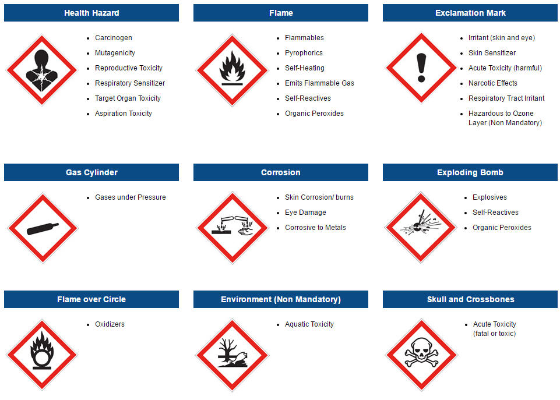
https://www.seton.com/resource-center/

Waste Label Examples

The below style of label is new to the Generator Improvement Rule. It can be used as the primary hazardous waste label.

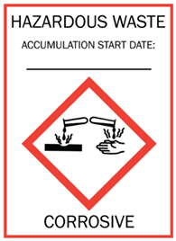

The below styles of labels are traditional and can continue to be used with the addition of a GHS Pictogram.
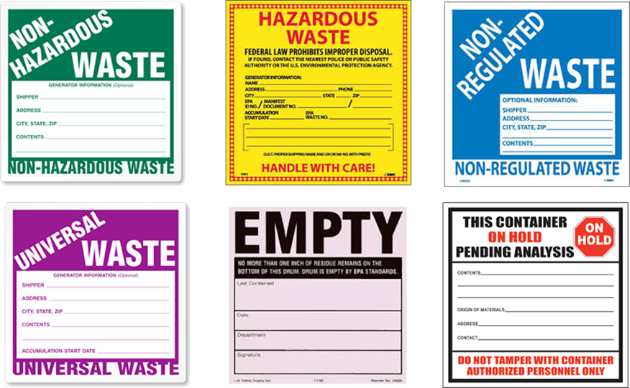
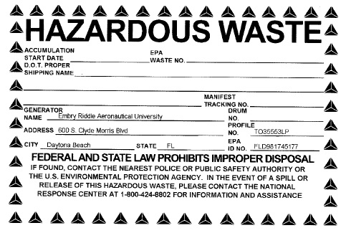

Accumulation Requirements

It is the responsibility of the Waste Generator to insure that waste accumulation areas are maintained in accordance with applicable rules and regulations. Waste can be accumulated in areas classified as "Satellite Accumulation Areas." The Waste Generator must ensure that the waste is being handled correctly on a day-to-day basis. The Waste Generator must also ensure that everyone in the lab/shop has read and is familiar with the Waste Satellite Accumulation Area Requirements.

Satellite Accumulation Area Requirements

- All hazardous wastes shall be accumulated in chemically compatible sealable containers.

- Containers shall be kept closed during accumulation except when adding waste to a container.
  - A funnel shall not be left in the container except for when a lockable/sealable funnel is installed to the container.

- Do not overfill chemical waste containers. 10% headroom is required for expansion.

- The exterior of the container must be free of chemical contamination. Call EH&S immediately if there is a leaking container.

- All containers that have free liquid in them must be placed on spill containment pallets.

- A container that is profiled/labeled as a solid waste (e.g. Flammable Solid Rag, Oily Rags) must not have any free liquid in the container.

- Keep incompatible waste separated from each other. Ensure that incompatible wastes are not accidently added to a waste container.

- For Hazardous Waste pickup, contact:
  - Daytona Beach- EH&S
  - Prescott-Campus Safety

- The Waste Generator is responsible for completing the weekly hazardous waste inspection log.

- A chemically compatible spill kit must be available and maintained at the Satellite Accumulation Area.

Waste Segregation

For waste management methods best practices and contracts ERAU currently uses to dispose of chemical waste, the following waste streams should be kept separate when possible.

- Flammable Liquids | - Mercury & Mercury Compounds
- Acids | - Ethidium Bromide
- Bases | - Formalin/Formaldehyde
- Oxidizers | - Chromerge
- Halogenated Organic Compounds | - Photographic Waste
- Non-halogenated Organic Compounds | - Aqueous Solutions
- Motor Oil | - Different Battery Chemistries
- Hydraulic Oil | - Each different type of Mercury Based lighting
- Air Reactive Materials | - Water Reactive Materials

Container Compatibility

It is vital that chemical waste be compatible with its container. If the waste is placed in an incompatible container, the container might disintegrate or rupture.

The following chemical wastes must be placed in glass containers. These chemicals cannot be placed in plastic High-Density Polyethylene (HDPE) containers or Metal Drums.

- Amyl chloride | - Brominated & Fluorinated Solvent
- Aniline | - P-Dichlorobenzene
- Benzyl Alcohol | - Diethyl Benzene
- Bromine | - Diethyl Ether
- Bromobenzene | - Ether
- Bromoform | - Ethyl Chloride, Liquid
- Butadiene | - Nitrobenzene
- Butyric Acid | - Perchloroethylene
- Carbon Disulfide | - Phenol / Chloroform Mixtures
- Cedarwood Oil | - Ntric Acid
- Chlorinated Solvents | - Thionyl Chloride
- Concentrated Acids | - Toluene
- Cinnamon Oil | - Trichloroethene
- Cresol | - Trichloroethylene
- Cyclohexane | - Vinylidene Chloride
- O-Dichlorobenzene | - Xylene  - D-Limonene (180 Day Restriction)

Flammable Liquid Wastes must be disposed of in metal drums that are grounded.

Wastes that are primarily water based shall be placed in plastic High-Density Polyethylene (HDPE) Containers.

Some acid/base waste can be put in Wastes that are primarily water based shall be placed in plastic High-Density Polyethylene (HDPE) Containers. Check compatibility to see if glass containers are required instead.

Containers can range from the original manufacturers chemical container to a secondary waste container such as a glass bottle. When these containers are shipped out, they must be placed in a “UN” marked package. Refer to the Hazardous Material Table to ensure proper packing group also.

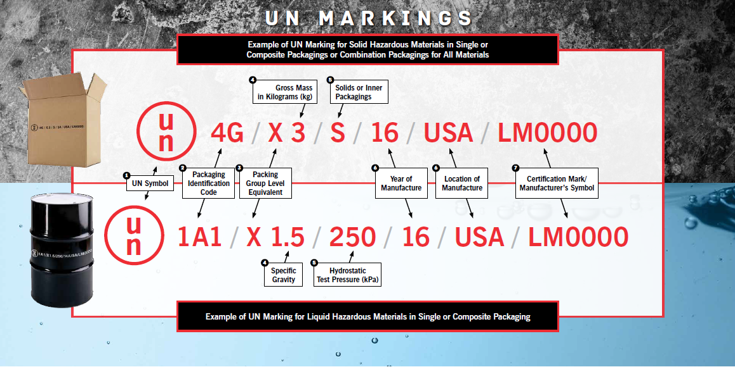

https://www.labelmaster.com/content/files/images/content-pages/resources/un-markings/un-markings-packaging-examples.png

Hazardous Waste Pickup Procedure

- In order to have hazardous waste picked-up from satellite accumulation areas, contact EHS. All pick-up scheduling will be done by EHS.

- The containers must be properly labeled.

- Access to the SAA must be available to EHS on pick-up day.

- Once the waste is removed from your area, ensure the weekly inspection form denotes a pick-up. Also, update your chemical inventory and/or request an MSDSOnline inventory change to EHS.

Landfill/Drain Waste Disposal

Disposal of chemicals into the sanitary sewer or municipal landfill is regulated by federal, state, and local laws and regulations. These laws and regulations prohibit drain disposal of hazardous waste and limit the discharge of a number of specific substances. Campus wastewater and solid waste stream may be monitored for violations of discharge limits.

Persons disposing of the chemicals are responsible for accessing and abiding by the SDS of the specific material and ensuring appropriateness for drain disposal. All drain or landfill disposal must be logged in a Nonhazardous Disposal Log that will be kept in the waste generating area or laboratory.

Drain or landfill disposal of chemicals is limited to occasional disposal of small amounts of non-hazardous chemicals. Large-scale or continuous disposal is permitted only with written approval of the EH&S office.

Class A Chemicals: Pose little or no hazard in landfill conditions or dilute aqueous solutions.
- Suitable for drain disposal up to 100g solute per laboratory per day.
- Suitable for landfill disposal up to 1kg per laboratory per day
Class B Chemicals: Pose moderate hazard in landfill conditions or dilute aqueous solutions but are not explicitly regulated. These chemicals either meet all of Class A requirements but also have a Category 1 or 2 for hazards designated with an exclamation mark pictogram or the CHO has determined the chemical lies close enough to Class A parameters to still allow for safe disposal in smaller quantities.
- Suitable for drain disposal with excess water in quantities no greater than 1g of solute per laboratory per day
- Suitable for landfill disposal up to 250g per laboratory per day
Class C Chemicals: Pose high hazard in landfill conditions or in dilute aqueous solutions. NOT suitable for drain disposal in any amount unless with written approval from the EH&S Office

Disposal Procedure:

- Check Drain & Landfill chart and Appendix A: Wastes Excluded from Solid Waste Regulation below to verify class of chemical. If the chemical is not on the list, contact EH&S to determine suitability for nonhazardous disposal.
- Check drain disposal log to verify that the desired drain disposal amounts will not violate the maximum allowable disposal
- If the above two steps are satisfactory:
  - For drain disposal: dispose of the material in a sink, running water for a minimum of 2 minutes for Class A and a minimum of 10 minutes for Class B to thoroughly flush the system.
  - For landfill disposal:
    - Carefully package the containers in a box for disposal, taking care to minimize potential for breakage.
    - All labels must remain undefaced and legible.
    - Seal the box with packing tape and use an indelible marker or label to indicated “Non-Hazardous Disposal”, the date, and the name of the PI or CHO.
- Record the disposal in the drain disposal log.

The following rules apply to nonhazardous DRAIN disposal for Class A:
HW Category | Parameters: | Acceptable for Drain | ✓ | Hazardous Waste | ✓
Ignitability | GHS "Flammable Liquid" Category (Acetone, Ethanol, Methanol, Isopropyl Alcohol are always Hazardous Waste) | Class ≥ 4 |  | Class < 4
Ignitability | If no GHS categories available, Flash Point | > 60°C |  | ≤ 60°C
Ignitability | GHS "Pyrophoric Liquid" Category | No |  | Yes
Ignitability | GHS "Substances and mixtures which emit flammable gases in contact with water | No |  | Yes
Reactivity | GHS "Oxidizing Liquid" Category | No |  | Yes
Reactivity | GHS "Organic Peroxides" Cateogry | No |  | Yes
Reactivity | GHS "Self-Reactive" Category | No |  | Yes
Corrosivity | GHS "Corrosive to Metals" Category | No |  | Yes
Toxicity | GHS "Acute Toxicity" Category | Class ≥ 5 |  | Class < 5
Toxicity | GHS "Acute Toxicity" Category | ORL-RAT LD₅₀ > 2500 mg/kg |  | ORL-RAT LD₅₀ ≤ 2500 mg/kg
Toxicity | GHS "Acute Toxicity" Category | SKN-RAT LD₅₀ > 4300 mg/kg |  | SKN-RAT LD₅₀ ≤ 4300 mg/kg
Toxicity | GHS "Acute Toxicity" Category | IHL-LC₅₀ >10,000 ppm |  | IHL-LC₅₀ ≤10,000 ppm
Toxicity | GHS "Germ Cell Mutagenicity" Category | No |  | Yes
Toxicity | GHS "Carcinogenicity" Category | No |  | Yes
Toxicity | GHS "Carcinogenicity" Category | < 10ppm |  | ≥ 10ppm
Toxicity | GHS "Reproductive Toxicity" Category | No |  | Yes
Toxicity | GHS "Aquatic Toxicity" Category | No |  | Yes
Toxicity | GHS "Aquatic Toxicity" Category | 96H LC₅₀ > 10,000ppm |  | 96H LC₅₀ ≤ 10,000ppm
Toxicity | P-listed | No |  | Yes
Misc. | Malodorous or Lachrymatory | No |  | Yes
Misc. | Lead | < 2.0 mg/L |  | ≥ 2.0 mg/L
Misc. | Mercury | < 0.02 mg/L |  | ≥ 0.02 mg/L
Misc. | Silver | < 0.4 mg/L |  | ≥ 0.4 mg/L
Misc. | Solubility in water | > 3% |  | < 3%
Misc. | pH | 5 - 10 |  | < 5 or > 10
Misc. | Organic chemical boiling point | ≥ 50°C |  | < 50°C
Misc. | Hydrocarbons, Nitro- and Oxygenated Organics | ≤5 Carbons |  | > 5 Carbons

Materials are not to be treated or diluted as a means of achieving drain disposal parameters.

The following rules apply to nonhazardous LANDFILL disposal for Class A:
HW Category | Parameters: | Acceptable for Drain | ✓ | Hazardous Waste | ✓
Ignitability | GHS "Flammable Solid" Category (Acetone, Ethanol, Methanol, Isopropyl Alcohol are always Hazardous Waste) | No |  | Yes
Ignitability | If no GHS, Flash Point | > 60°C |  | ≤ 60°C
Ignitability | GHS "Combustible Dust" Category | No |  | Yes
Ignitability | GHS "Pyrophoric Solid" Category | No |  | Yes
Ignitability | GHS "Substances and mixtures which emit flammable gases in contact with water | No |  | Yes
Ignitability | Organic chemical boiling point | ≥ 50°C |  | < 50°C
Reactivity | GHS "Self-Reactive" Category | No |  | Yes
Reactivity | GHS "Oxidizing Solid Category | No |  | Yes
Reactivity | GHS "Organic Peroxides" Cateogry | No |  | Yes
Corrosivity | GHS "Corrosive to Metals" Category | No |  | Yes
Toxicity | GHS "Acute Toxicity" Category | Class ≥ 5 |  | Class < 5
Toxicity | GHS "Acute Toxicity" Category | ORL-RAT LD₅₀ > 2500 mg/kg |  | ORL-RAT LD₅₀ ≤ 2500 mg/kg
Toxicity | GHS "Acute Toxicity" Category | SKN-RAT LD₅₀ > 4300 mg/kg |  | SKN-RAT LD₅₀ ≤ 4300 mg/kg
Toxicity | GHS "Acute Toxicity" Category | IHL-LC₅₀ >10,000 ppm |  | IHL-LC₅₀ ≤10,000 ppm
Toxicity | GHS "Germ Cell Mutagenicity" Category | No |  | Yes
Toxicity | GHS "Carcinogenicity" Category | No |  | Yes
Toxicity | GHS "Carcinogenicity" Category | < 10ppm |  | ≥ 10ppm
Toxicity | GHS "Reproductive Toxicity" Category | No |  | Yes
Toxicity | GHS "Aquatic Toxicity" Category | No |  | Yes
Toxicity | GHS "Aquatic Toxicity" Category | 96H LC₅₀ > 10,000ppm |  | 96H LC₅₀ ≤ 10,000ppm
Toxicity | P-listed | No |  | Yes
Misc. | Malodorous or Lachrymatory | No |  | Yes
Misc. | Lead | < 2.0 mg/L |  | ≥ 2.0 mg/L
Misc. | Mercury | < 0.02 mg/L |  | ≥ 0.02 mg/L
Misc. | Silver | < 0.4 mg/L |  | ≥ 0.4 mg/L

Embry-Riddle Aeronautical University
Drain Disposal Log
Principal Investigator: __________________________________

Building: ____________________ Room:___________

Class A Chemicals: Up to 100g solute per laboratory per day (e.g. 100g of ethanol in 1L water)
Class B Chemicals: Up to 1g solute per laboratory per day
Class C Chemicals: NOT suitable for drain disposal in any amount unless with written approval from EH&S Office.

Date | Chemical | Volume (mL) | Cumulative Daily Volume (mL) | Class | Initials
Embry-Riddle Aeronautical University
Landfill Disposal Log
Principal Investigator: __________________________________

Building: ____________________ Room:__________

Date | Chemical | Quantity (g) | Cumulative Daily Quantity (g) | Appendix IV Listed | Initials

Spill Cleanup Procedure

If there is an immediate danger to life or property, contact Campus Safety and the Facilities Management Department immediately. For any spill, contain the spill if possible and safe to do so. Evacuate the area if the area is unsafe. Spills that occur after normal working hours shall be reported to Campus Safety. Campus Safety will contact EHS and Facilities Management. EHS MUST BE NOTIFIED IMMEDIATLY AFTER ANY SPILL.

Each laboratory and shop area shall have a chemically compatible spill kit. Small chemical spills must be contained and cleaned up immediately. All flames should be extinguished and spark-producing equipment turned off if capable; activate the fire alarm via fire alarm pull station. Evacuate the building and call Campus Safety.

The responder will take steps to ensure that the spill site is contained and does not spread any further if able to do so safely. If the scene is considered unsafe, Campus Safety should set up a perimeter and evacuate zones as necessary. When safe to do so, the Safety Data Sheet must be accessed so that clean-up procedures will be effective.

After cleaning up the spill, place the chemical and absorbent in a compatible container with a Hazardous Waste label on it. Ensure that the Hazardous Waste label identifies the absorbent and the chemical(s). After the spill is contained, complete a Spill Incident Report Form on the ERNIE EHS page. Submit to EH&S within 8 hours of a spill.

Special Wastes

- Unknowns - Special effort should be exercised to prevent the generation of unknown wastes. Since characterization of unknown wastes significantly increases the cost of disposal. To have unknowns picked-up, place a Hazardous Waste label on the container with the word "Unknown" in the constituent’s column. When an “Unknown” is discovered contact EH&S immediately.

- Gas Cylinders - Generators should attempt to establish accounts with suppliers who will allow the return of unused product and empty cylinders. If possible, the entire contents of the cylinder should be used up. Generators must ensure that aging cylinders are picked up by contacting EH&S before the integrity of the valve and cylinder is compromised. The department will be billed directly for cylinders that require special handling and disposal procedures such as unknown or old cylinders.

- Peroxide Formers - Must be requested to be picked up by EH&S sub-contractors. Common peroxide formers are ethyl ether, ethylene glycol, dimethyl ether (glyme), vinyl ethers, isopropyl ether, potassium metal, and sodium amide.

- Ethidium Bromide - Concentrated stock solutions must be handled as a hazardous laboratory waste. Researchers concerned about discarding gels or solutions with lower or questionable amounts will need to have them handled as a hazardous laboratory waste. If a lab chooses to decontaminate their ethidium bromide, the filter and/or resin beads must be handled by EH&S sub-contractors.

- Reagents - The following reagents contain mercury and should be handled as hazardous waste:
- Dobbin's Reagent | - Tyrosine Reagents
- Millon's Reagent | - Jacquemart's Reagent
- Hayem's Solution | - Sachsse's Solution
- Morell's Solution | - Knapp's Solution
- Hopkins-Cole Reagent | - Spiegler's Reagent
- Nessler's Reagent | - Tanret's Reagent
- Rohrbach's Solution | - Meyer's Solution
- Flemming's Solution (osmium, chromic acid) | - Folin-Dennis Solution (mercuric cyanide)
- Fisher's Reagent (phenyl hydrazine) | - Erlicki's Solution (chromium)

- Dinitro and Trinitro Compounds - These compounds must be picked up by EH&S sub-contractors before the contents have dried. Some are potentially shock sensitive when the moisture content is less than 10%. Picric acid is a common example of this type of compound.

- Photochemical – EH&S recommends that labs which use large quantities of photo chemicals have a silver recovery unit installed. This unit treats the fixer so that it may be discharged down the drain. If a silver recovery unit is not used, call EH&S. Do not handle the fixer. No concentrated photo chemicals of any kind can be placed in the trash or sink.

- Spilled Materials - The spilled chemical and the absorbent must be packaged and handled as either Hazardous/Non-Regulated Waste. The Hazardous Waste label must name the chemical(s) and the absorbent used.

- Used Oil - All vacuum pump oil, synthetic oil, transmission and brake fluids, lubricating greases, etc., must have the words "Used Oil" on the container.

- Used Oil Filters – All used oil filters must be placed in a drum or tote that must have the words “Used Oil Filter” on the container. Call EH&S for FREE disposal.

- Batteries - Alkaline batteries can be disposed of in the trash. Lead acid batteries should be taken to Facilities Management. Other batteries which contain hazardous metals such as mercury, lead, silver and cadmium must be placed in separate containers that are properly labeled.

- Paint – Latex-based paints are typically non-hazardous. Excess latex-based paints are to be brought to Facilities Management for free disposal. Excess oil based paints are considered hazardous waste. Used spray paint cans are collected in drums as a Flammable Hazardous Waste. The nozzle and cap must be removed before placing in drum.

- Light Bulbs – Fluorescent, mercury projector lamps and high-intensity discharge (HID) bulbs are collected in drums at Facilities Management.

- Pharmaceutical Waste - There are many chemical and/or pharmaceutical compounds that are used in the treatment of diseases that are also considered by the EPA to be hazardous wastes when disposed. Call EH&S or refer to the Pharmaceutical Waste guide for further guidance (Appendix C).

- Mercury Containing Devices - Many types of equipment contain elemental mercury. Separate the mercury from the equipment only if it is safety to do so and will not result in a spill. Mercury containing devices must be disposed / recycled by EH&S. Examples include:

- Heating and air conditioning thermostats
- Tilt switches used in silent light switches, chest type freezers
- Pressure gauges, displacement/plunger relays
- Flow meters
- Sump pump float switches
- Thermometers, manometers (blood pressure gauge)

Appendix A: Wastes Excluded from Solid Waste Regulation
Wastes Which Are Not Solid Wastes | 40 CFR Citation for the Exclusion
Domestic Sewage and Mixtures of Domestic Sewage | §261.4(a)(1)
Point Source Discharge | §261.4(a)(2)
Irrigation Return Flow | §261.4(a)(3)
Radioactive Waste | §261.4(a)(4)
In-Situ Mining | §261.4(a)(5)
Pulping Liquors | §261.4(a)(6)
Spent Sulfuric Acid | §261.4(a)(7)
Reclamation in Enclosed Tanks | §261.4(a)(8)
Spent Wood Preservatives | §261.4(a)(9)
Coke By-Product Wastes | §261.4(a)(10)
Splash Condenser Dross Residue | §261.4(a)(11)
Hazardous Secondary Materials From the Petroleum Refining Industry | §261.4(a)(12)
Excluded Scrap Metal | §261.4(a)(13)
Shredded Circuit Boards | §261.4(a)(14)
Pulping Condensates Derived from Kraft Mill Steam Strippers | §261.4(a)(15)
Spent materials generated within the primary mineral processing industry from which minerals, acids, cyanide, water, or other values are recovered by mineral processing or by beneficiation | §261.4(a)(17)
Petrochemical recovered oil from an associated organic chemical manufacturing facility | §261.4(a)(18)
Spent caustic solutions from petroleum refining liquid treating processes used as a feedstock to produce cresylic or naphthenic acid | §261.4(a)(19)
Hazardous secondary materials used to make zinc fertilizers | §261.4(a)(20)
Zinc fertilizers made from hazardous wastes, or excluded hazardous secondary materials | §261.4(a)(21)
Used cathode ray tubes (CRTs) | §261.4(a)(22)
Hazardous secondary material generated and legitimately reclaimed within the United States or its territories and under the control of the generator | §261.4(a)(23)
Hazardous secondary material that is generated and then transferred to a verified reclamation facility for the purpose of reclamation is not a solid waste | §261.4(a)(24)
Solvent-contaminated wipes that are sent for cleaning and reuse are not solid wastes from the point of generation | §261.4(a)(26)
Hazardous secondary material that is generated and then transferred to another person for the purpose of remanufacturing is not a solid waste | §261.4(a)(27)

Solid Wastes Which Are Not Hazardous Wastes | CFR Citation for the Exclusion
Household Hazardous Waste | §261.4(b)(1)
Agricultural Waste | §261.4(b)(2)
Mining Overburden | §261.4(b)(3)
Fossil Fuel Combustion Waste (Bevill) | §261.4(b)(4)
Oil, Gas, and Geothermal Wastes (Bentsen Amendment) | §261.4(b)(5)
Trivalent Chromium Wastes | §261.4(b)(6)
Mining and Mineral Processing Wastes (Bevill) | §261.4(b)(7)
Cement Kiln Dust (Bevill) | §261.4(b)(8)
Arsenical-Treated Wood | §261.4(b)(9)
Petroleum Contaminated Media & Debris from Underground Storage Tanks | §261.4(b)(10)
Injected Groundwater | §261.4(b)(11)
Spent Chloroflurocarbon Refrigerants | §261.4(b)(12)
Used Oil Filters | §261.4(b)(13)
Used Oil Distillation Bottoms | §261.4(b)(14)
Landfill Leachate or Gas Condensate Derived from Certain Listed Wastes | §261.4(b)(15)
Project XL Pilot Project Exclusions | §261.4(b)(17)
Project XL Pilot Project Exclusions | §261.4(b)(18)

Appendix B: TOXICITY CHARACTERISTICS

8 HEAVY METALS
ARSENIC
BARIUM
CADMIUM
CHROMIUM
LEAD
MERCURY
SELENIUM
SILVER

10 PESTICIDES
2,4-D
ENDRIN
HEPTACHLOR (AND ITS EPOXIDE)
HEXACHLOROBENZENE
HEXACHLOROBUTADIENE
HEXACHLOROETHANE
LINDANE
METHOXYCHLOR
TOXAPHENE
2,4,5-TP (SILVEX)

22 ORGANIC CHEMICALS
BENZENE
CARBON TETRACHLORIDE
CHLORDANE
CHLOROBENZENE
CHLOROFORM
O-CRESOL
M-CRESOL
P-CRESOL
CRESOL
1,4-DICHLOROBENZENE
1,2-DICHLOROETHANE
1,1-DICHLOROETHYLENE
2,4-DINITROTOLUENE
METHYL ETHYL KETONE
NITROBENZENE
PENTRACHLOROPHENOL
PYRIDINE
TETRACHLOROETHYLENE
TRICHLOROETHYLENE
2,4,5-TRICHLOROPHENOL
2,4,6-TRICHLOROPHENOL
VINYL CHLORIDE

Appendix C: Pharmaceutical Wastes

There are many chemical and/or pharmaceutical compounds used in research or in the treatment of diseases that are also considered by the EPA to be hazardous waste when disposed of. Listed below are some common materials found at ERAU.

Note: This list is provided as a guide only and is not all-inclusive.

Commonly Used Medical Products

These products, for disposal purposes, may also be regulated as hazardous wastes and are commonly found in medical use or research.

Diethylstilbestrol Epinephrine
Hexachlorophene Nicotine
Nitroglycerine Phenacetin
Resorcinol Reserpine
Saccharin

Heavy Metals

Arsenic, Lead and Nickel Cadmium (batteries) compounds are commonly used in medical equipment. Chromium is found in many nutritional supplements. Mercury is found in preservatives (Thimerosol), thermometers, sphygmomanometers and antiseptics. Selenium is found in ointments (selenium sulfide), shampoos and nutritional supplements. Silver can be found in burn ointments (Silvadene), styptic sticks (silver nitrate) and some antiseptics.

EPA Regulated Chemicals with Medicinal Uses

The following is a list of compounds that may have medicinal, pharmacological, research or other similar uses.

Chemical
Acetone
Acetyl Chroride
Acrylonitrile
Aniline
Azaserine
3-Benzyl Chloride
Bromoform
Cacodylic Acid
Carbon Tretachloride
Chloral
Chlornaphazin
p-Chloro-m-cresol
2-Chloroethyl vinyl ether
Chloroform
Creosote
Cresol
Chloropropionitrile
Dichlorobenzene
Diisopropylfluorophosphate
Dimethylamine
Dimethylphenethylamine
Ethyl Acetate
Ethyl Cabamate
Ethyl Oxide
Ethyl Ether
Formaldehyde
Hexachloroethane
Lindane
Maleic Anhydride
Methanol
Methapyrilene
3-Methylcholanthrene
Methylthiouracil
Napthtlalene
Paraldehyde
Phenol
Sodium Diethyl dithiocarbamate
Physostigime Salicylate
Physostigime
Potassium Silver Cyanide
Strychnine
Tetrachloroethylene
Trichloroethylene
Thiram
Warfarin

Use
Pharmaceutic aid (solvent)
Testing for cholesterol
Used in pharmaceutical mfg
Used in pharmaceutical mfg
Sedative, hypnotic, antitussive
Dermatologic
Anthemlmintic, pharmaceutic aid (solvent)
Mfg. of chloro hydrate
Antineoplastic
Antiseptic
Mfg of anesthetics and sedatives
Anesthetic
Mgr of anesthetics and sedatives
Anesthetic
Antiseptic, expectorant
Antiseptic, disinfectant
Used in pharmaceutical synthesis
Germicide, used in pharmaceutical mfg.
Cholinesterase deactivator
Used in pharmaceutical mfg
Adrenergic
Pharmaceutic aid (flavoring agent)
Antineoplastic
Surgical instrument sterilizer
Disinfectant, anesthetic
Antiseptic, disinfectant, preservative
Anthelmintic
Scabicide
Mgr of pharmaceuticals
Solvent used in the mfg. of pharmaceuticals
Antihistaminic
Used in experimental cancer research
Thyroid inhibitor
Antiseptic anthelmintic
Sedative, hypnotic, controlled substance
Antiseptic, anesthetic, antipruritic
Ni/Cd poisoning antidote
Chlolinergic
Chlolinergic
Bactericide
Veterinary tonic and stimulant
Anthelmintic
Inhalation anesthetic, mfg. of pharmaceuticals
Antiseptic
Anticoagulan

Appendix D: Hazardous Waste Determination Form
Generation Location: |  | Generator Name: (generator any person, whose act or process produces a hazardous waste)
Building: | Room:
Chemical/ Waste Name: |  | Contact Phone Number:
Generation Process: (how was the waste created)

Estimated Generation Rate: (Within 6 months)
5 Gal 16 Gal 30 Gal 55 Gal > 55 Gal Tank
Attachments: (attach all applicable documentation describing the waste (e.g. Acceptable Generator Knowledge, sample analysis, SDS , SOP etc.):
Physical State:  - Solid  - Solid with freestanding or absorbed liquid  - Liquid: If liquid, indicate if the liquid is:  - Single – Layer  - Multi - Layer  - Gas  - Aerosol |  |  | Characteristics: (Select all that apply)  - Ignitable/Oxidizer (D001)  - <140°F  - Corrosive (D002)  - pH ≤ 2  - ≥12.5  - Reactive(D003)  - Toxic (D004-D043)  - A selected group of eight (8) heavy metals, ten (10) pesticides, and twenty-two (22) organic chemicals are classified as hazardous due to their toxicity characteristic.  - Radioactive
Listed: (see attached waste codes)
- “F” Listed: (F001-F037)
- Non- Specific Source Wastes
- “P” Listed: (P001-P123)
- Acutely Toxic Hazardous Waste
- “U” Listed: (U001-U359)
- Toxic if not otherwise identified by another hazardous waste characteristic
Selected Waste Codes:
______ ______ ______ ______ ______ ______
Material Condition:
- Is expired

- Does not have current use

- Has a waste like appearance?

Composition: (list all hazardous constituents, must equal 100%)
Compound: |  | Volume% (range) | Compound: | Volume% (range)
1. |  |  | 4.
2. |  |  | 5.
3. |  |  | 6.
Pictograms: (Check all that apply)

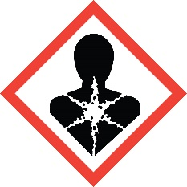 | 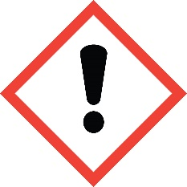 | 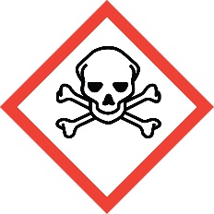 | 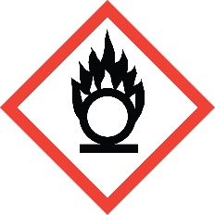 | 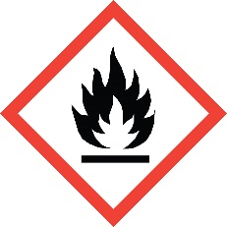
Health Hazard | Exclamation Mark | Acute Toxicity | Flame Over Circle (Oxidizer) | Fire Hazard
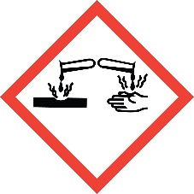 | 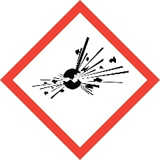 | 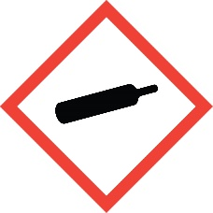 | 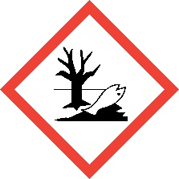
Corrosive | Explosives | Compressed Gas | Environment (Aquatic Toxicity)

Final Determination:

Hazardous Non-Hazardous Medical waste Universal waste Used oil Prohibited by POTW
Generator signature: _______________________________________ Date: ____________

Approved by EHS: __________________________________________ Date: ____________

