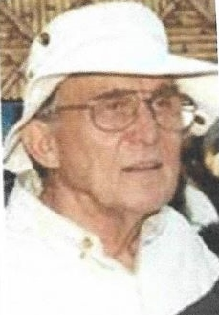
Charles J. Sedgwick

Dr. Sedgwick (Washington State ’57), 86, a pioneer of zoological medicine, died May 26, 2018, in Monterey, California. After several years in private practice, he became Charter Zoo Veterinarian for the new Greater Los Angeles Zoo in 1964, at a time when there were fewer than 10 zoo veterinarians in the US (most of whom were directors rather than clinicians). Using two experimental immobilizing drugs and older techniques, he moved all animals from the old Los Angeles Zoo to the new facility. In the process, anesthesiology became his main interest. In 1969, he became Research Veterinarian for the UCLA/NASA Biosatellite II program (monkeys in space), when monkeys were used in a ground control group, as well as in space flight, prior to sending a human into space.

His long career included being Director of Veterinary Services at the San Diego Zoo, 1970 to 1976. He held a faculty post at UC Davis, 1976 to 1983, as Campus Veterinarian and Course Director/Lecturer in Zoological and Laboratory Animal Medicine and Clinician at the Sacramento Zoo. Then at Tufts University, 1983 to 1995, he was Associate Professor & Course Director of Comparative Medicine and Zoological Medicine in the Department of Environmental Studies, and first Director of the Tufts Wildlife Center. His last major position was a return to the Los Angeles Zoo as Chief Zoological Veterinarian, 1995 to 2000. He was instrumental in designing and building new animal hospitals at the San Diego and Los Angeles zoos. In retirement, he concentrated on writing algorithms to fine-tune allometric scaling for use in calculating drug dosages for various species.

Charles (Chuck) Sedgwick was friend and mentor to many people who have studied zoo animal or lab animal medicine (including Dr. Murray Fowler, who shadowed him for a year at the San Diego Zoo while gathering information and photos for the first edition of Zoo and Wild Animal Medicine). He was exceptional in his ability to relate to students, on the job and in the classroom. His respect for students as individuals, his warmth, and good humor set him apart from many busy professionals.

Dr. Sedgwick was a Diplomate of ACZM and ACLAM. His honors include the Lifetime Achievement Award from AAZV, Excellence in Teaching and Research from WSU (2010), and Lifetime Achievement Award from the National Wildlife Rehabilitators Association.

Predeceased by his beloved wife, Shirley, Dr. Sedgwick is survived by his three sons -David, Michael, and Paul- and their families.

