ADI San Antonio Texas Nov 5th, 2022

2022 Annual Awards:
International Dentist of the Year
Michael Glick DMD

Michael Glick is an American dentist, professor and researcher. He served as editor of the Journal of the American Dental Association (JADA) from 2005 until 2020 and as dean of the State University of New York at Buffalo School of Dental Medicine until August 14, 2015.
Glick, whose father was a dentist, was born in Sweden and was trained in dentistry at the Hebrew University Hadassah School of Dental Medicine in Jerusalem, Israel and Temple University Dental School in Philadelphia, Pennsylvania. He completed graduate work in oral medicine at the University of Pennsylvania School of Dental Medicine.^{[2]} After finishing his training he founded one of the first dental clinics in the US dedicated to treating patients infected with HIV.^{[4]}
Before being appointed dean of SUNY Buffalo Dental School, Glick was professor of oral medicine and associate dean for oral and medical sciences at the A.T. Still University School of Osteopathic Medicine in Mesa, Arizona from January 1, 2007. Prior to that, he was professor and chair of oral diagnostic sciences at New Jersey Dental School and on the faculty at UPenn Dental in the department of oral medicine. Glick was a practicing dentist in Delaware and Pennsylvania for 15 years.
In December 2004, Glick was chosen as the editor of JADA, having been the associate editor for dentistry and medicine since 1998. He also served as president of the American Board of Oral Medicine.^{[3]} Glick has given more than eight hundred presentations in more than thirty different countries.
In July 2021, Glick was named the Executive Director of the University of Pennsylvania's Center for Integrative Global Oral Health
Glick is the editor of ten textbooks on dental management and oral medicine, and has published over three hundred articles on health-related topics

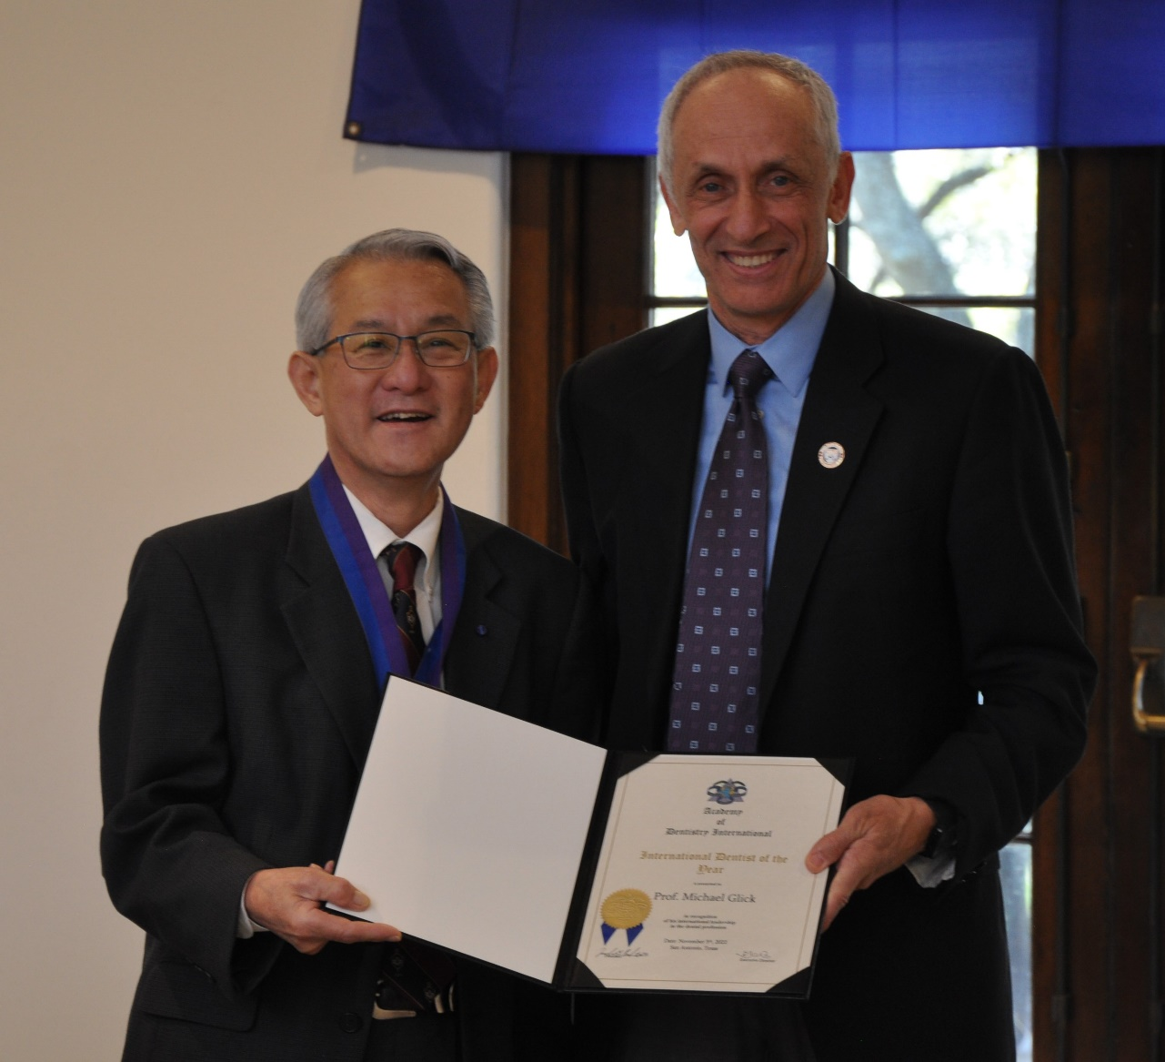

Humanitarian Award
Dr. Ronald Fritz DDS MPH
Shortly after earning his professional degrees, Dr. Fritz spent six years on a deferred mission appointment working in a private, non-profit clinic, Policlinica Bella Vista, and served as dental director of Bella Vista Hospital, in Mayaguez, Puerto Rico.
In 1978, Dr. Fritz opened a private practice in Escondido, California, that utilized calming verbal imagery as well as IV Sedation to relax patients with dental phobias, simultaneously serving on the staff of Palomar Memorial Hospital where he took cases that required treatment under general anesthesia.
Dr. Fritz spent five years working for Loma Linda University at its SAC Health System’s Norton Dental Clinic performing oral surgery for four general dentists.
Dr. Fritz’ cynosure is the delivery of oral health care to the neediest people, and, given his fluency in Spanish, especially those in Latin America. In January of 2016, where the group from Imperial Valley provided much needed care and education to outlying poor areas in rural Huatulco and Puerto Escondido. He has been on similar service trips to Bolivia, Peru, Ecuador, Galapagos Islands, Colombia, Guyana, and Brazil as well as to Mexico, India, China, Micronesia, and multiple islands in the Caribbean.
Dr. Fritz is a member of the American Dental Association, California Dental Association, Colegio de Cirujanos Dentistas de Puerto Rico, and the San Diego County Dental Society, where he has chaired its Well Being Committee. He also helps the Flying Samaritans and Los Medicos Voladores (Flying Doctors) with their missions of mercy to the underserved in California and Mexico.
Dr. Fritz is a fellow of the American Association of Hospital Dentists (1982), the Academy of General Dentistry (1983), the Academy of Dentistry International (2005), the International College of Dentists (2009), the American College of Dentists (2010), the Pierre Fauchard Academy (2012), and is fellow emeritus, the Academy of General Dentistry (2014).
