FOR IMMEDIATE RELEASE
JUNE 2023

ASSOCIATION OF IMAGE CONSULTANT INTERNATIONAL (AICI)
Global Creativity Conference Announces Transition in Presidency

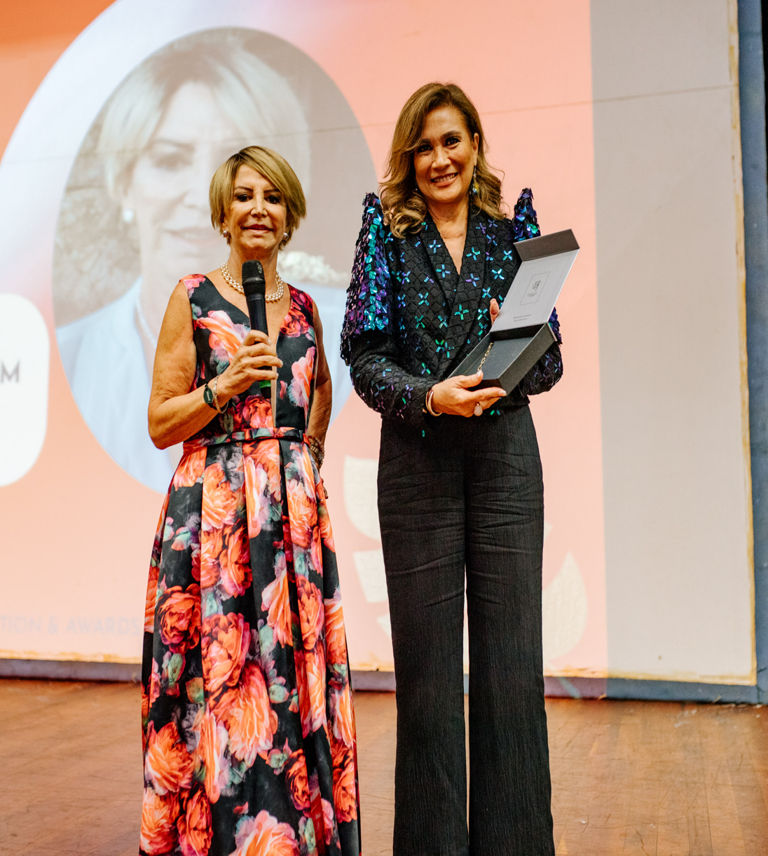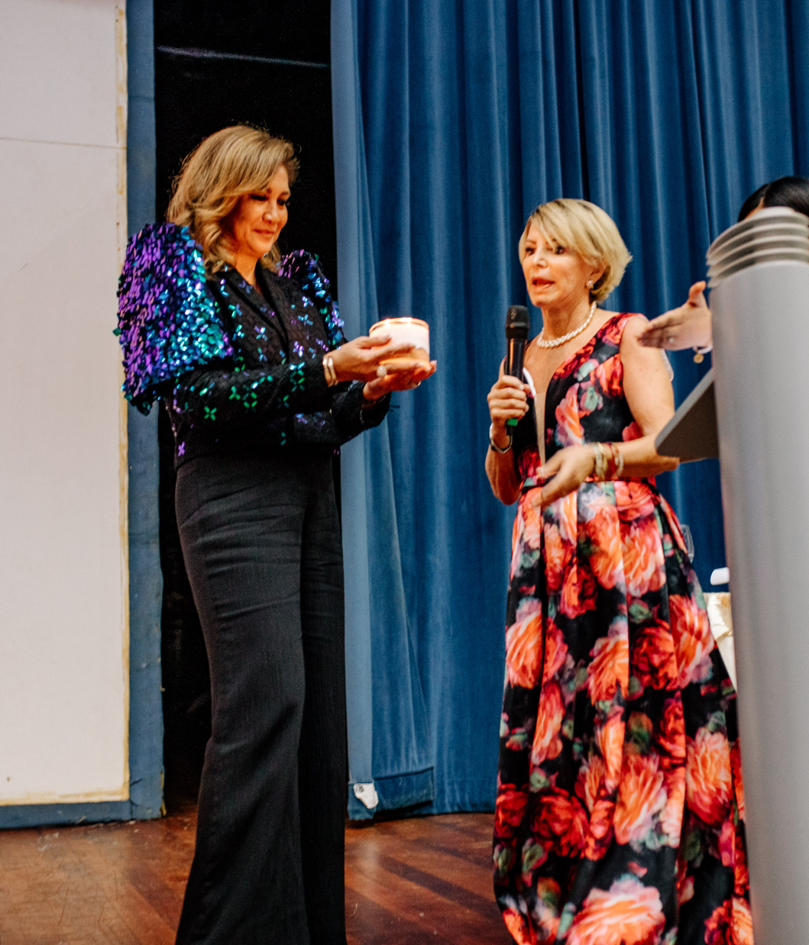

PUNTA CANA, DOMINICAN REPUBLIC — The Association of Image Consultants International (AICI) the leading and largest professional association of personal and corporate image consultants worldwide, is pleased to announce a successful turnover of the presidency. Following an extensive tenure, Lilian Bustamante, AICI CIM has handed over the reins to Olen Juarez-Lim, AICI CIP effective July 1, 2023. The seamless transition ensures continuity and sets the stage for a new phase of growth and innovation within the organization.

During Lilian's tenure, AICI experienced remarkable advancements, transforming into a premier platform for image industry professionals, and enthusiasts worldwide. Under their visionary leadership, the association witnessed substantial growth, expanded strategic partnerships, and introduced pioneering initiatives that have left a lasting impact on its membership.

As Lilian Bustamante passes the baton to Olen Juarez-Lim, AICI anticipates a continued trajectory of success. Olen brings a wealth of experience and expertise in image and business, making her an ideal candidate to lead AICI into the future. Her proven track record of accomplishments, combined with their passion for the image consulting industry, will undoubtedly steer AICI towards new milestones and achieve even greater heights.

The transition in presidency signifies a commitment to sustained excellence and the pursuit of innovation and professionalism within the organization. AICI's mission remains steadfast in fostering collaboration, knowledge sharing, and networking opportunities among professionals and industry partners in the image consultancy field. The incoming president, Olen Juarez-Lim, is poised to build upon the AICI's legacy, enhance its global reach, and introduce transformative initiatives that address the evolving needs and challenges of the industry.

"I am honored to have served as the president of AICI and to have witnessed its remarkable growth over the years," said outgoing President Lilian Bustamante. "I have full confidence in Olen's abilities to lead the association forward, and I look forward to witnessing its continued success under her guidance."

Olen Juarez-Lim expressed gratitude and enthusiasm for the opportunity, stating, "I am truly humbled and excited to take on the role of president of AICI. I am committed to building upon the exceptional work of my predecessor and further positioning the association as a global leader in the image industry. Together with the esteemed global board and our passionate members, I am eager to contribute to the advancement of our industry and provide an enriching experience for all members."

The AICI global membership extends its heartfelt appreciation to Lilian Bustamante for her outstanding leadership, dedication, and invaluable contributions. Her tenure has created a solid foundation for AICI's future growth and success.

For more information about the AICI Global Creativity Conference, including future events and initiatives, please visit www.aici.org or contact vpmarketing@aici.org. Media inquiries can be directed to Shubha Joshi, VP Marketing at vpmarleting@aici.org.

About AICI
The Association of Image Consultants International (AICI)is the leading and largest professional association of personal and corporate image consultants worldwide. AICI connects image professionals to a diverse global community that: inspires creativity; builds knowledge and expertise; and creates sustainable impact on individuals, businesses, and the world.
AICI members counsel both, individual and corporate clients on appearance, behavior, communication, and soft skills. As experts in image consulting, our professionals guide clients to achieve their specific goals with authenticity, credibility, and confidence.

For media inquiries, please contact:
vpmarketing@aici.org
www.aici.org

