FOR IMMEDIATE RELEASE

ASSOCIATION OF IMAGE CONSULTANT INTERNATIONAL (AICI)
Global Creativity Conference Inspires Innovation and Collaboration

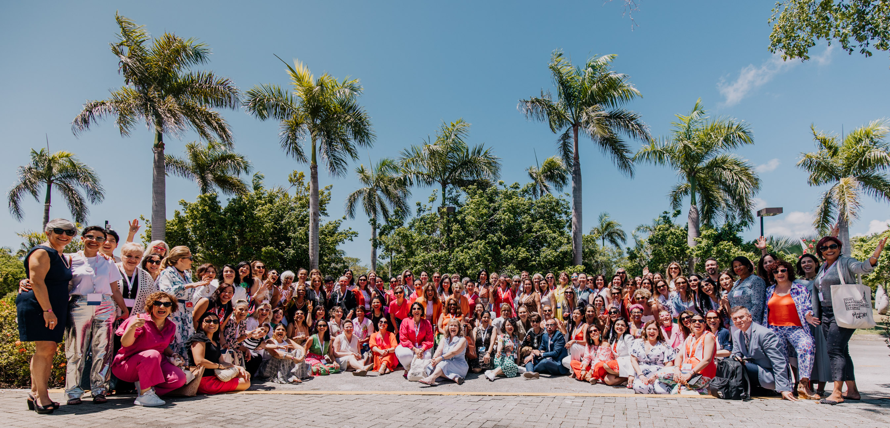

PUNTA CANA, DOMINICAN REPUBLIC — The Association of Image Consultants International (AICI) recently concluded its highly successful and impactful global conference bringing together leading experts, thinkers, and members from around the world. The conference, held from June 8 – 11, 2023 provided a platform for thought-provoking discussions, creative exploration, and collaborative networking, fostering a dynamic environment conducive to unlocking the boundless potential of human creativity.

The Global Creativity in Action Conference aimed to ignite fresh ideas, stimulate breakthrough thinking, and encourage cross-disciplinary collaborations. The conference attracted a diverse array of participants, including professionals, educators, and entrepreneurs, all united by their passion for pushing the boundaries of innovation.

Throughout the four-day event, attendees were treated to an impressive lineup of keynote speeches, interactive workshops, panel discussions, and hands-on activities, all designed to explore the multifaceted aspects of creativity and its profound impact on society. Renowned experts from various fields shared their insights, experiences, and best practices, encouraging participants to embrace new perspectives and challenge conventional norms.

AICI Global Creativity in Action Conference showcased a wide range of topics, including image and style, confidence and empowerment thinking, metaverse technologies, creative problem-solving, sustainability, entrepreneurship, and much more. Attendees had the opportunity to delve into emerging trends, engage in lively interactions, and gain practical knowledge from industry leaders, empowering them to foster innovation in their respective fields.

One of the highlights of the conference was the Creative Runway where participants was treated to witness unique pieces crafted from sustainable and upcycled materials, featuring handmade embroidery and traditional elements blended with contemporary shapes. The curation and styling have been diligently carried out by dedicated AICI models, who have made significant efforts to showcase their local fashion and bring designers to the runway who prioritize mindful designs and materials.

Furthermore, the global conference highlighted achievements and facilitated valuable networking opportunities, enabling delegates to connect with like-minded individuals and establish meaningful professional relationships. Participants were able to forge new partnerships, explore potential collaborations, and build a global community committed to advancing the mission, vision, and values of AICI.

"We are thrilled with the overwhelming response to the global conference," said Lilian Bustamante, President of AICI. "The conference served as a catalyst for inspiring conversations, fresh insights, and transformative experiences. We firmly believe that creativity is a driving force behind societal progress, and the conference has played a pivotal role in fostering a global ecosystem of creativity and innovation."

The success of the AICI Global Creativity Conference has left an indelible mark on the creative landscape, empowering individuals, and organizations to push the boundaries of imagination and achieve extraordinary outcomes. As participants return to their respective communities armed with newfound knowledge and inspiration, the impact of the conference is expected to resonate far beyond its conclusion.

For more information about the AICI Global Creativity Conference, including future events and initiatives, please visit www.aici.org or contact vpmarketing@aici.org.

###

About AICI
The Association of Image Consultants International (AICI)is the leading and largest professional association of personal and corporate image consultants worldwide. AICI connects image professionals to a diverse global community that: inspires creativity; builds knowledge and expertise; and creates sustainable impact on individuals, businesses, and the world.
AICI members counsel both, individual and corporate clients on appearance, behavior, communication, and soft skills. As experts in image consulting, our professionals guide clients to achieve their specific goals with authenticity, credibility, and confidence.

For media inquiries, please contact:
vpmarketing@aici.org
www.aici.org

