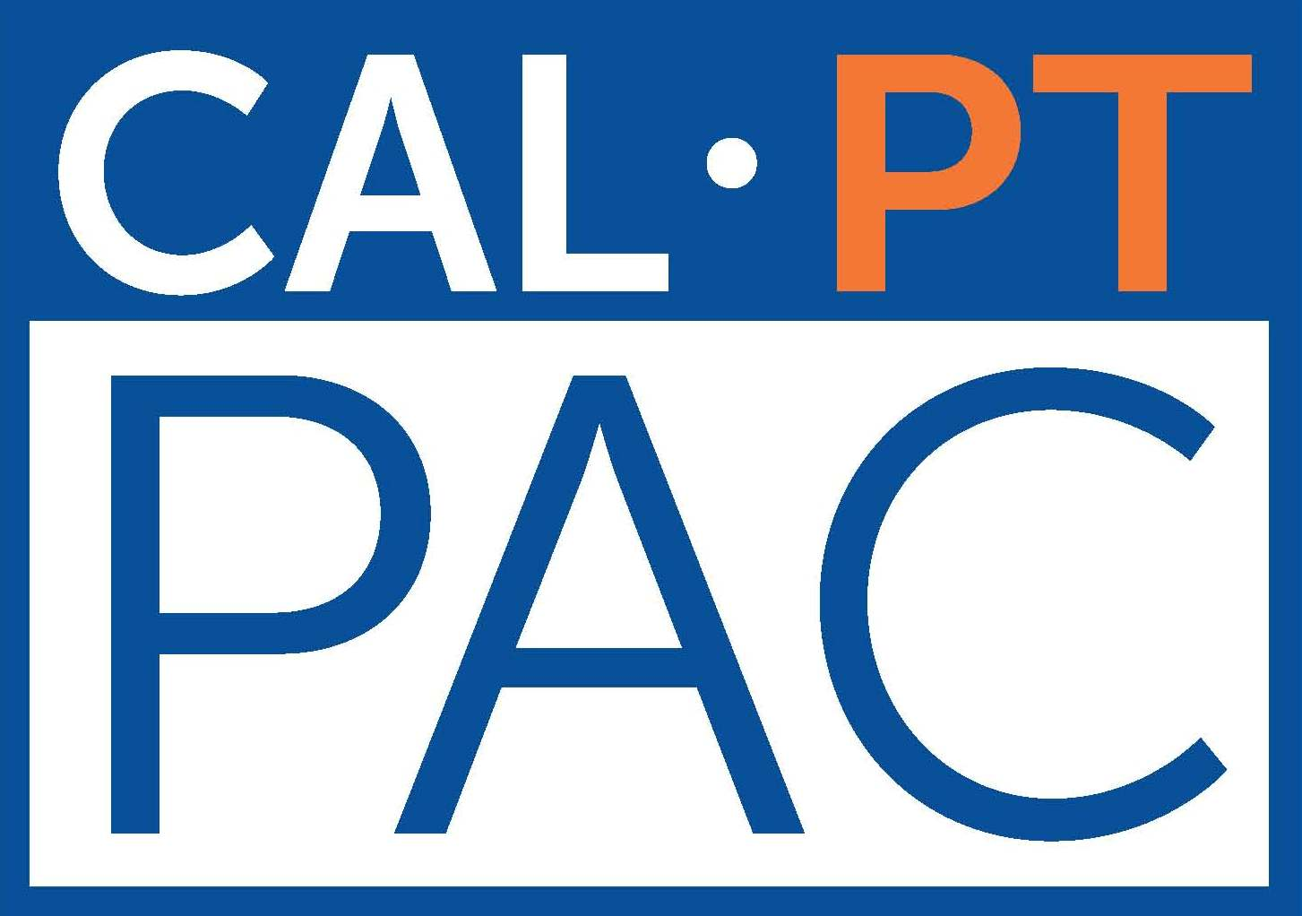

Thank You
2019
CAL‐PT‐PAC VIP Student Cub Donors

___________________________________
Jessica Phung, SPT

