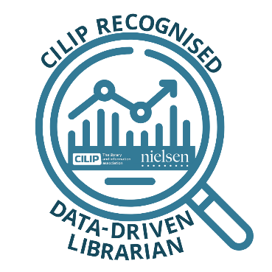CILIP recognised course on

DATA DRIVEN LIBRARIANSHIP

Powered by Nielsen Book

**Session 3: Research**

**How being informed about the trade and loan market trends and performance can aid with your stocking decisions**

*Optional task to do after the session*

Requirements: a license for LibScan via https://online.nielsenbookscan.net/ (obtained only if

your library is a LibScan participant)

**Task:**

You have noticed that your library users are borrowing more computer guides. Using LibScan

extract a chart of your library’s most loaned computer-related titles for the year to date and

compare them to the books loaned across the whole libraries panel. For the latter case also look

at the same chart of YTD for the prior year.

* What can you conclude from these charts about what books you should be stocking?
* Do you believe your library has thorough enough coverage of the category or is it dominated by only a few titles?
* Are there any titles that you should be stocking to cover any shortfalls?

If you would like to have feedback on your findings then please email no more than 300 words

to: [hazel.kenyon@nielseniq.com](mailto:hazel.kenyon@nielseniq.com) with the subject: **Data driven Librarian: LibScan Task** and

we will aim to get back to all of you.