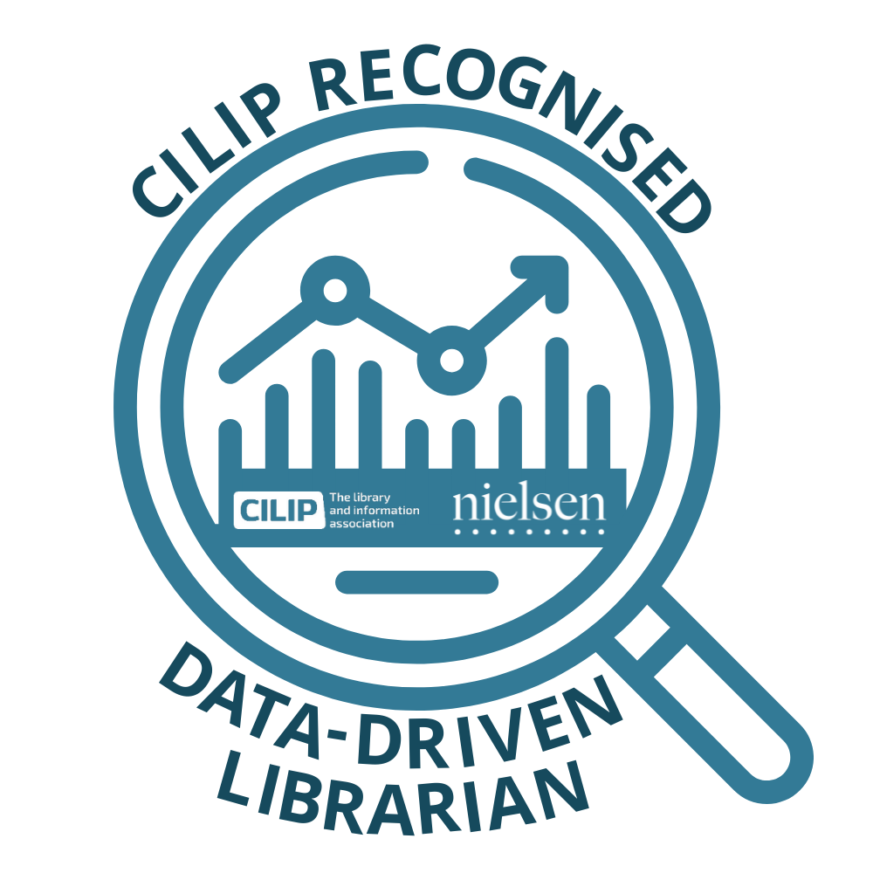

CILIP recognised course on

DATA DRIVEN LIBRARIANSHIP

Powered by Nielsen Book

**Session 1: Discovery Part 1**

The questions below have been designed to measure your understanding of the first session in the series.

Please select one answer for each question and then use the answer sheet to mark and complete this component of your Self-Assessment.

**Section 1: The Wider Supply Chain**

Question 1: Which of the following organisations rely on accurate metadata information in their day-to-day operations:

|  |  |
| --- | --- |
| 1. Library suppliers & wholesalers |  |
| 1. Retailers |  |
| 1. Libraries outside of the UK |  |
| 1. ALL of the above a, b and c |  |

Question 2: What is the accreditation scheme (awarded to Nielsen Book for 2021-22) that was designed by BIC for libraries and their suppliers for their adoption of best practice and industry standards and their investment in beneficial technologies?

|  |  |
| --- | --- |
| 1. EDITeur |  |
| 1. TEILA Accreditation |  |
| 1. BIC Simply Excellence Accreditation |  |
| 1. LDA Librarian Data Award |  |

**Section 2: Metadata Creation**

Question 3: What are considered the three most important aspects for any QUALITY bibliographic record that will help a book to be discovered across discovery platforms?

|  |  |
| --- | --- |
| 1. Longest words, largest number of images, largest number of contributors |  |
| 1. Detailed synopsis, marketing brochure, high-profile author |  |
| 1. Accurate, timely, complete |  |
| 1. Vague information, last-minute, skeleton record |  |

Question 4: What is usually considered to be the FIRST and most important step in creating a metadata record?

|  |  |
| --- | --- |
| 1. Assigning an ISBN |  |
| 1. Sharing the marketing and promotional information |  |
| 1. Adding the price |  |
| 1. Giving the weights and dimensions of the book |  |

Question 5: In the Nielsen Book Metadata Report research on library borrowings, we found that titles that carried ALL FOUR key metadata elements of **long and short descriptions, author biographies, reviews and jacket images** enhanced library catalogues and online presence increasing the average borrowings significantly above those with NO descriptive elements. How much on average did the borrowings increase by compared to those with zero descriptive elements?

|  |  |
| --- | --- |
| 1. 10% |  |
| 1. 25% |  |
| 1. 57% |  |
| 1. 167% |  |

Question 6: Which of the following would **NOT** be defined as a basic metadata field:

|  |  |
| --- | --- |
| 1. ISBN |  |
| 1. Title |  |
| 1. Cover image |  |
| 1. Keywords |  |

Question 7: How many elements make up an ISBN?

|  |  |
| --- | --- |
| 1. 3 |  |
| 1. 4 |  |
| 1. 5 |  |
| 1. 6 |  |

Question 8: What is the maximum number of characters required for a short description in a metadata record?

|  |  |
| --- | --- |
| 1. Up to 1,000 |  |
| 1. Up to 2,500 |  |
| 1. Up to 450 |  |
| 1. Up to 350 |  |

**Section 3: Using Metadata to support stock selection and populate library catalogues**

Question 9: Surrey Libraries has used Nielsen Book data to revitalise its Junior Non-Fiction borrowing, what percentage increase did they see?

|  |  |
| --- | --- |
| 1. 47% |  |
| 1. 55% |  |
| 1. 57% |  |
| 1. 61% |  |

Question 10: The British Library uses Nielsen Book data sets to manage its legal deposit workflows. What year did the legal deposit become law?

|  |  |
| --- | --- |
| 1. 1662 |  |
| 1. 1664 |  |
| 1. 1665 |  |
| 1. 1668 |  |

***Thank you for completing this part of your Self-Assessment, the next step is to mark your answers using the ‘Answer Sheet’ and update the Self-Assessment checklist.***