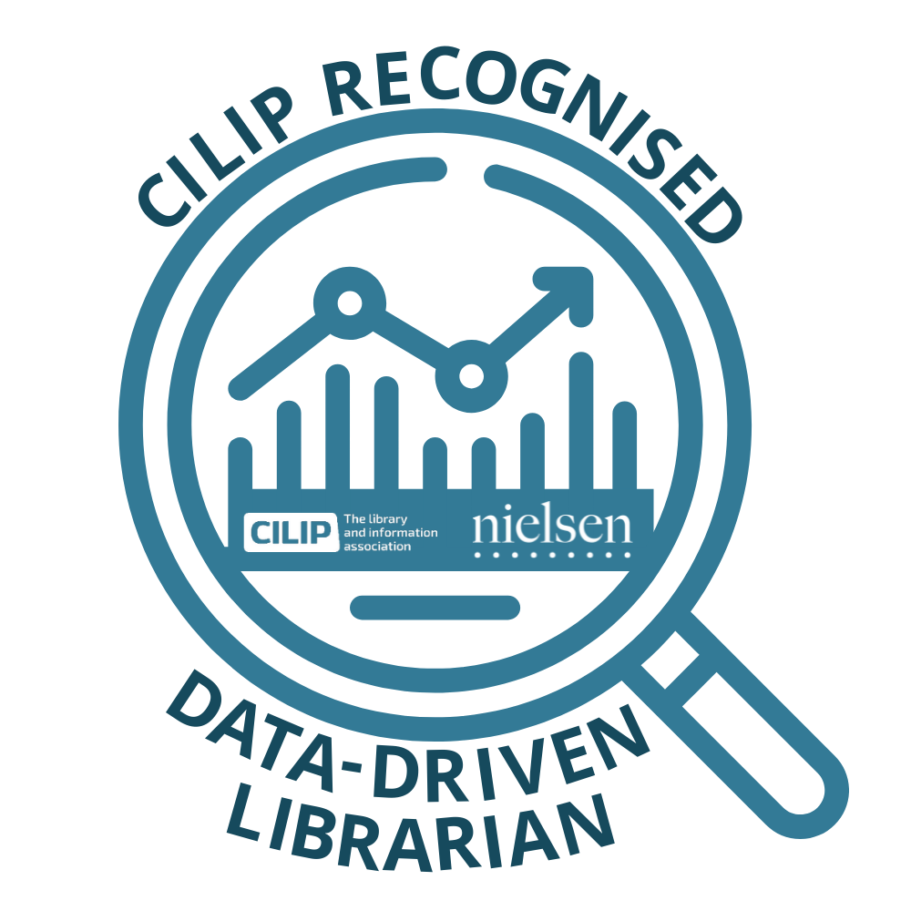

CILIP recognised course on

DATA DRIVEN LIBRARIANSHIP

Powered by Nielsen Book

**Session 2: Discovery Part 2**

The questions below have been designed to measure your understanding of Thema, covered in the second session in the series.

Please select one answer for each question and then use the answer sheet to mark and complete this component of your Self-Assessment.

**For each of the books below, which is the best Primary Thema Subject Code?**

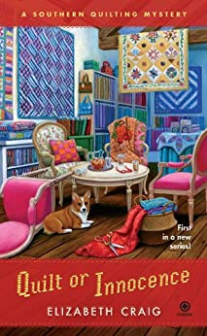Question 1: Quilt or Innocence

|  |  |
| --- | --- |
| 1. WFBQ Quiltmaking, patchwork & appliqué |  |
| 1. FFJ Crime and mystery: cosy mystery |  |
| 1. 1KBB-US-S US South |  |

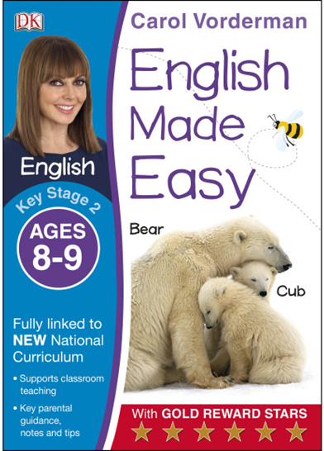

Question 2: English Made Easy

|  |  |
| --- | --- |
| 1. 2ACB English |  |
| 1. VSL Adult literacy guides / handbooks |  |
| 1. YPCA1 Educational: First / native language: Basic literacy |  |

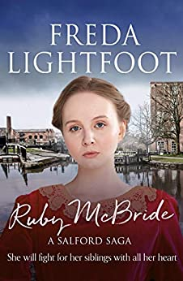

Question 3: Ruby McBride

|  |  |
| --- | --- |
| 1. DBS Ancient Sagas & epics |  |
| 1. FT Generational sagas |  |
| 1. 1FPJ-JP-HB Saga |  |

Thank you for completing this part of your Self-Assessment, the next step is to mark your answers and update the Self-Assessment checklist.