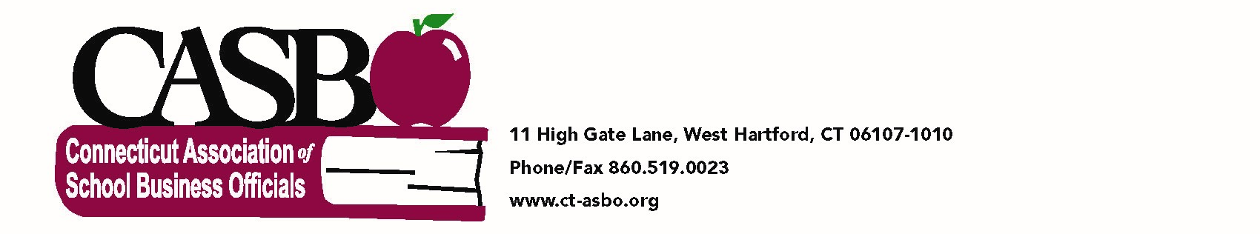Aggregate spending for education for each school

During the closing of the 2014 legislative session, CT State Statute 10-222o was enacted. This required the posting of certain classification of expenditures by school to be reported by each district on its local website annually. The statute is enclosed for reference.

CASBO formed a taskforce to review and make recommendations to comply with this requirement. The objective was to:

- Standardize reporting data across all districts
- Utilize existing data
- Create a template that could be used by districts to comply
- Ensure that, as closely as possible, data would agree with information already supplied to the SDE thus avoiding conflicts

Upon reviewing of the existing information already being prepared, it was determined that two basic documents could be utilized to accomplish the objective.
- The Final ED001 Schedules 4 and 12
- The October PSIS enrollment by school as well as the report called Summary of Selected Fields by School.

From schedule 12 the appropriate lines will be:
- Line 1214 - Total expenditures for elementary, middle school or junior high school regular education services
- Line 1215 - Total expenditures for secondary/high school regular education services
- Line 1216 - Special Education Expenditures reported in Schedule 4 Line 412, Column 3

The enclosed worksheet can be utilized to enter the information so that a final summary can be developed and posted to the local school district’s website.

In the committee work, there were two approaches as to how best to display the special education tuition requirement. The first was to capture the aggregate amount and not allocate it to each school. The second approach was to distribute this to each school and not report the tuition as a separate number. This decision is left up to the local school districts as to how they want to handle it.

The worksheet has highlighted areas to enter the required data. To facilitate
Line 1214, there are ten (10) lines made available. If more rows are needed, just insert them. If you need less, you can either delete rows not needed or leave them blank.
Line 1215 has four (4) lines available. If more rows are needed, just insert them. If you need less, you can either delete rows not needed or leave them blank.
To report this on your website it is suggested that the results be published as a separate page on under your district website and the following be utilized as an introduction to the data.

Aggregate spending on education for each school of XXXXXX District
As of June 30, XXXX

This financial data is presented in accordance with CT State Statute 10-222o, which requires each local and regional board of education to annually publish on their website the aggregate spending for education for each school under their jurisdiction. Please note that aggregate spending includes, but is not limited to, funding sources such as the locally approved school budget, all in-kind services provided by the local municipality/city, all Federal and State grants, insurance claims, rentals, donations, and endowment funds. Total expenditures have been disaggregated and presented by school and by special education tuition as required.

The following information reflects the aggregate spending for the period 7/1/XX to 6/30/XX.

Please note: Since there was not a date which the data must be posted, the committee discussed publishing this once each year and to do it after the FINAL ED001 is audited to avoid any confusion between data supplied to SDE and the local data. Since the audits must be submitted by December 31st, it was the consensus of the committee to publish the data by January 31st each year.

CGS 10-222o.

Sec. 10-222o. Information re aggregate spending for education to be made available. (a) For the fiscal year ending June 30, 2014, and each fiscal year thereafter, each local and regional board of education shall annually make available on the Internet web site of such local or regional board of education the aggregate spending on salaries, employee benefits, instructional supplies, educational media supplies, instructional equipment, regular education tuition, special education tuition, purchased services and all other expenditure items, excluding debt service, for each school under the jurisdiction of such local or regional board of education.
- For the fiscal year ending June 30, 2014, and each fiscal year thereafter, each regional educational service center shall annually make available on the Internet web site of such regional educational service center the aggregate spending on salaries, employee benefits, instructional supplies, educational media supplies, instructional equipment, regular education tuition, special education tuition, purchased services and all other expenditure items, excluding debt service, for each school under the jurisdiction of such regional educational service center.
- For the fiscal year ending June 30, 2014, and each fiscal year thereafter, the governing authority for each state charter school shall annually make available on the Internet web site of such governing authority the aggregate spending on salaries, employee benefits, instructional supplies, educational media supplies, instructional equipment, regular education tuition, special education tuition, purchased services and all other expenditure items, excluding debt service, for each state charter school under the jurisdiction of such governing authority.
(P.A. 13-247, S. 192.)

