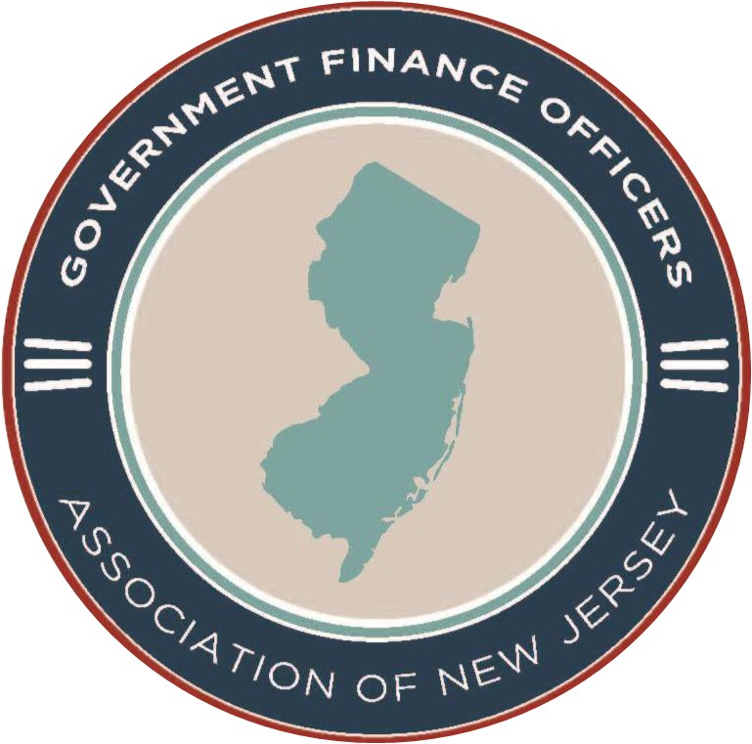

A Professional Association of Government Finance Officers
President | 150 West State Street, Suite 200
Lori Russo | Trenton, NJ 08608
Executive Director | G.F.O.A. Hotline: (609) 394-1155
John Donnadio, Esq. | Fax: (609)-989-8567  Email: info@gfoanj.org
Dear Member:

This Fall, the Government Finance Officers’ Association will be holding a Northern NJ Social on Friday, November 6th, 2026, at Sear House Restaurant, 1 NJ 23, Little Falls, New Jersey 07424 sponsored by Kearny Bank.

Registration is FREE and open to the first 35 GFOA members who register, CEUs and CPEs applied for.

10:00 AM Registration/Continental Breakfast

10:20-11:10 Class 1

11:10-11:20 Break

11:20-12:10 Class 2

12:15-2:00 Luncheon
-------------------------------------------------------
ENCLOSED PLEASE FIND MY REGISTRATION FOR THE NORTHERN NJ SOCIAL
PLEASE RESPOND BY November 4, 2026

NAME _________________________________________________________________

MUNICIPALITY/COUNTY

POSITION

TELEPHONE NUMBER

EMAIL__________________________________________________________________

Please send registration to: GFOA of NJ
Email: info@gfoanj.org
FAX: 609-989-8567

