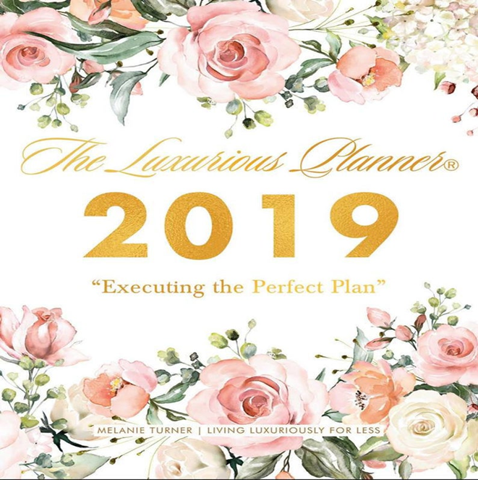
Welcome

Events by Channy B invites you into a world where your dreams can become a Reality.

Take Comfort in knowing that your wedding will be handeled with great care. Every facet of your wedding will be handeled metculously . Below you will find a variety of wedding packages to fit your Budget. Please feel free to contact us for any questions you may have.

About us
Events by Channy B was created on August 21st, 2018. We were created on the passion and the love we had for helping people create their Dreams into reality. My love for event planning awakened while planning a Birthday party for My Best friend and Myself. After planning my Birthday party, I realized this is what i wanted to do I loved the feeling of planning and Designing. I’m the owner and head leader of Events by Channy B. Also, I’m a Certified Wedding and Event planner.

Our Mission is to make any Event your having stress free so you can enjoy your special day without the hassle of worrying. We offer affordable package plans so you can choose which one is right for your Budget. We do everything for you from finding the perfect Venue, food,entertainment,Attire,Arrival and Appreciation. I look forward to making your vision into a reality so that you can create memories with your loved ones on your special day.
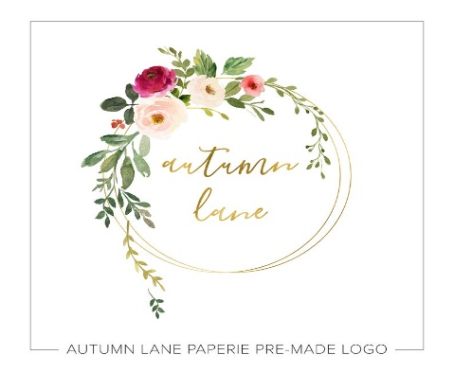
Events by Channy B

Day of Service Contract
Events By Channy B Wedding Planner Contract (the “Contract”) is entered into ____________________ (the “Effective Date”), by and between ________________________, with an address of _____________________________ (the “Client”) and _________________, with an address of _______________________________, (the “Planner”), collectively “the Parties.”
1. Wedding Details.
Wedding Date: ___________________________________________________________
Ceremony Location: _______________________________________________________
Reception Location: _______________________________________________________

2. Planner Duties. Client engages Planner’s services to perform the following duties with regard to the Event:
• Unlimited consultations via email and/or telephone.
Planner’s Telephone Number: _________________________________________
Planner’s Email Address: _____________________________________________
Client’s Telephone Number: __________________________________________
Client’s Email Address: ______________________________________________
• Unlimited face to face consultations. Be advised, extra costs will be incurred for travel expenses if the meeting is more than __ miles from Planner’s home/office.
• Assistance with budget and breakdown of costs.
• Discussion of and development of theme/style for Wedding.
• Find all suppliers and/or service providers.
• Management and coordination with Ceremony and Reception location personnel.
• Management of all suppliers and/or service providers. Be advised, extra costs will be incurred for travel expenses for any travel more than __ miles from Planner’s home/office.
• Visit ceremony and reception location prior to Wedding Day.
• Provide a detailed timeline to suppliers and/or service providers and bridal party.
• Confirmation and follow-up with all suppliers and/or service providers 1-2 weeks prior to Wedding Day.
• Day of coordination and supervision until ________________________________.

1. Payment. The Parties agree to the following Payment and Payment Terms:
Total Fee for Services: _____________________________________________________
Non-Refundable Deposit Due Upon Execution of Agreement: ______________________
Balance Due: ____________________________________________________________
Balance Due Date: ________________________________________________________
Most of the services we contract on your behalf, Such as Transportation, musicians , videographers , photographers and etc are contracted on time basis . If these times are exceeded Events by Channy B have the right to charge you any excess billing fee. We will add additional time to your credit card on file and send you an acknowledgement by email, text or phone call.
2. Cancellation.
By Client. Client may cancel this Agreement at any time. If Client cancels up to ____ days prior to the Event Date, it will be entitled to a full refund. If Client cancels between up to ______ days prior to the Event Date, it will be entitled to a fifty percent (50%) refund. If Client cancels less than 60 days prior to the Event Date, it will not be entitled to a refund.
By Planner. Planner may cancel this Agreement at any time. If Planner cancels, it must provide a suitable, replacement Planner, subject to Client’s approval, which shall be obtained in writing. In the alternative, Planner shall refund all monies previously paid by Client, with the exception of any non-refundable deposits, which were agreed to by Client.
3. Planner Limitation of Liability. Planner will do its best to find top suppliers and/or service providers. However, the Planner does not guarantee any suppliers’ and/or service providers’ performance and/or product. Planner will not be responsible for any supplier and/or service provider performance and/or product. In the event Client changes the date of the Wedding, Planner will make every effort to accommodate, but Planner’s availability is not guaranteed for any other date than the date stated above.

4. Dispute Resolution and Legal Fees. In the event of a dispute arising out of this Contract that cannot be resolved by mutual agreement, the Parties agree to engage in mediation. If the matter cannot be resolved through mediation, and legal action ensues, the successful party will be entitled to its legal fees, including, but not limited to its attorneys’ fees.

Severability. In the event any provision of this Agreement is deemed invalid or unenforceable, in whole or in part, that part shall be severed from the remainder of the Agreement and all other provision 1. should continue in full force and effect as valid and enforceable.
1. Legal and Binding Agreement. This Agreement is a legal and binding between the Parties as stated above. This Agreement may be entered into and is legal and binding both in the United States and throughout Europe. The Parties each represent that they have the authority to enter into this Agreement.
2. Governing Law and Jurisdiction. The Parties agree that this Agreement shall be governed by the State and/or Country in which both Parties do business. In the event that the Parties do business in different States and/or Countries, this Agreement shall be governed by _________ law.
3. Entire Agreement. The Parties acknowledge and agree that this Agreement represents the entire agreement between the Parties. In the event that the Parties desire to change, add, or otherwise modify any terms, they shall do so in writing to be signed by both parties.
If However certain events beyond our control like weather should happen or prevent us from meeting our standards, Events By Channy B is to be blameless. Nevertheless, we will do everything in our ability to assist with the situation that is outside of our normal control.

The Parties agree to the terms and conditions set forth above as demonstrated by their signatures as follows:

“CLIENT”
Signed: _____________________________________
By: ________________________________________
Date: _______________________________________

“PLANNER”
Signed: _____________________________________
By: ________________________________________
Date: ______________________________________

How to Obtain an New York
Marriage License
Obtaining a Marriage License:

You may Obtain a Marriage License in Brooklyn New York at this current location: Brooklyn City Clerk
Brooklyn Municipal Building
210 Joralemon St, Room 205
Brooklyn, NY 11201
Phone Number:1718-802-4107
8:30 am - 4:00pm / M-F
(except for court Approved holidays)

Marriage License Fee $35
Requirements:
- Both you and your spouse must appear at the office of the City Clerk in person together to obtain their marriage license.
- Your photo Identification documentation must be current and valid.
- Provide documentation of previous marriage
- Fee is $35 Cash payment is acceptable

Application Requirements:

- Both spouses must list their name
- Current Address
- City, State
- Zip code and country
- Country of birth
- Name and country of both your parents
- Social Security number
- If you were married, The divorce decree or death certificate
- All divorce annulments and dissolutions must be finalized before you apply for a new marriage.

Marriage ID Requirements New York:

- Eight forms of Identification are accepted. Expired ID is not accepted.
- A government-issued photo ID
- a. Driver’s License, Non-Driver’s license and learner's permit with photographs
- b. State ID Card
- c. Passport
- d. Military ID
- passport
Age Requirement
- You both must be 18 years old

Waiting period
- A 24 hour wait period right after you and your prospective spouse to obtain your license required by the New York State Law.

Civil Ceremony
- Get a marriage license. State rules vary, but you will probably need to get this within 30 days of your planned civil ceremony date. It will also cost about 50 dollars, and you may need to take with you a copy of your birth certificate or other form of identification.

- you will still need 2 witnesses to be at the civil ceremony to sign the marriage certificate.

-A Civil ceremony is just as legal as a religious ceremony in the United States. In fact, the religious ceremony becomes legal when the officiant signs the civil license. The wedding certificate paperwork comes with a form for ordering extra copies of your marriage license, which you will need for making changes to insurance, banks, credit cards, etc. Either of you can change your last name on the license paperwork.

Wedding Party check List

Maid of Honor

- Helping the bride to choose the bridesmaids' dresses
- Addressing invitations and if necessary, helping to create favors
- Supervising the attendants for fittings and rehearsals
- Holding the groom's ring at the ceremony
- Tending to the bride's needs and her gown
- Holding the bride's bouquet at the ceremony
- Overall, helping to reduce the stress of the bride Plan and host a bridal shower As gifts come in, maintain updated list of wedding gifts for thank you cards Keep ribbons and bows from shower gifts to create a “bow-quet” for rehearsal Help select a gift to the bride from bridesmaids Purchase a wedding gift and shower gift Plan a bachelorette party (travel, costs, activities, guests, etc.) Attend as many pre-wedding events as possible Help make sure all bridesmaids are at rehearsal and on time Attend the rehearsal and rehearsal dinner Make your contact information available to guests, friends, and family for wedding questions (gifts, events, etc.) Create a “bride survival kit” Be there emotionally for bride Be available two days prior to wedding for last minute ideas and questions
- Holds the grooms wedding ring
- Witness the signing of marriage certificate

Bridesmaids

- Pay for own wedding attire and travel expenses
- Help gather guests for the first dance, cake cutting, and bouquet toss
- Walk in processional and recession
- Dances with ushers and single male guests.
- Helps gather guests for the first dance, cake cutting, and bouquet toss.
● Participates in bouquet toss, if single.
● Looks after the couple’s elderly relatives and friends.
● Pays for own wedding attire and transportation to the wedding.
Possibly hosts or co-hosts a bridal shower.

Best Man

● Organizes a pre-wedding party for the groom.
● Coordinates the ushers’ gift to the groom. (Usually one gift)
● Attends the rehearsal and rehearsal dinner.
● Gets the groom dressed and to the ceremony on time.
● Makes sure the groom’s wedding expenses are prepared. (Officiant’s fee, tips, etc.)
● Makes sure the groom has his marriage license and ring with him.
● Delivers any payment to the Officiant, musicians, and sextons as prearranged.
● Enters the sanctuary with the groom.
● Holds the bride’s wedding ring during the ceremony.
● Makes sure all ushers are properly attired and in place on time.
● Walks in recessional.
● Witnesses the signing of the marriage certificate.
● Drives the bride and groom to the reception, if no driver is hired.
● Helps to welcome guests at the reception.
● Offers the first toast to the bride and groom at the reception

Mother of the Bride

● Hosts an engagement party.
● Helps the couple in finding a site or helps with other big planning decisions.
● Usually contributes to the wedding budget.
● Assists the bride in putting together the guest list.
● Suggests special family or ethnic ceremony traditions.
● May help bride to shop for wedding gown and accessories.
● Chooses own wedding day outfit. (Coordinates with wedding party.)
● May plan or host a bridal shower with the bridesmaids.
● On wedding day, helps bride to get ready.
● May accompany husband and daughter to the ceremony.
● Walks in recessional with husband following the bridal party

Mother of Groom

● Contacts the mother of the bride if the families are not yet acquainted.
● Attends the engagement party if the bride’s family hosts one.
● Along with husband, may host an additional engagement party on the groom’s side of the family.
● Usually contributes to the wedding budget.
● May help the couple decide on sites and help with other big planning decisions.
● Helps to put together the guest list.
● Suggests special family or ethnic ceremony traditions.
● May help the bride shop for her wedding gown.
● Chooses own wedding day outfit. (Coordinates with wedding party.)
● Along with husband, plans or hosts a rehearsal dinner.
● Escorted out following the wedding party and the bride’s parents.
● Greets guests in the receiving line.
● May be announced along with husband at the wedding reception.
● Sits in an honored place at the parents’ table.
● Does a mother-son dance with groom.
● Attends post-wedding brunch. (If held)
Flower Girl

● In the processional, walks alone directly before the bride and her father.
● Scatters flower petals from a small basket or nosegay of flowers.
● In the recessional, walks with the ring bearer, directly behind the couple.

Groomsmen

Contributes to usher’s gift to the groom. (Usually one gift)
● Attends rehearsal and rehearsal dinner.
● Reviews special seating arrangements before ceremony with head usher. ● Greets guests as they arrive.
● Seats elders first if groups arrive.
- Planning the bachelor party
- Helping with the gift to the groom from the ushers
- Attending the rehearsal dinner
- Getting the groom to the ceremony on time
- Delivering the payment to the clergy
- Holding the bride's wedding ring
- Coordinating the ushers
- Offering the first toast to the bride and groom

Wedding Package

Luxury Package
Starting at $10,000

This package includes full service. We do everything for you from beginning to end this package is so you can enjoy your special day without worrying because we do it all for you. This is some of what the package includes:

- Invitations
- Overnight hotel rooms accommodations
- Bridal Car
- Car service for the guest from the hotel to the church
- Wedding Cake
- Gifts
- Guest book
- Photo & video coverage
- 2-hour use of photo booth
- Church decoration
- Reception decorations
- Flower decorations
- Bouquet for bride
- Bouquet for maid of honor
- Cater
- Attire
- Entertainment
- Tablecloths
- chairs
- Centerpieces
- Linens
- Event planner & workers

Diamond Package
Starting at $5,000

This is a partial package meaning not everything is included. We also work the Day of with setting up for your special day.

- Venue
- Cater
- Tablecloth
- Linens
- Centerpieces
- Photographer
- Invitations
- Gifts
- Cake

Individual Add-ons

Individual add ons is if you need anything like DIY decorations are just extra Linens, Tablecloths and Centerpieces.

Essay

Events by Channy B will focus on wedding and event planning. I never thought about planning Weddings I was more into Birthday parties and Baby showers. After selling my service project for weddings and events I would love to focus on doing weddings too, so that will be something added. The Services I will be including to my business plan is having my own Venue space so that my Clients won’t have to spend extra money. I will also have different types of design chairs, Tables and Tablecloths to rent if my clients need any.
I'm still strategizing on my business plan that will set me apart from others, but I know I’m very creative. I love to do DIYS so I that will set me apart from others. My goal in one year from now is to start my own business but still learn or shadow under someone. Five years from now I’ll have my own Venues. Ten years from now I want to have my own Event spaces in New York and Atlanta also other places to keep building. I want to have a venue, event plan and have an updated store where you can come and get anything for an event from chair rentals, linens decoration anything you need to make an event happen in one store.

FAQ For Planners

  - Why do we need an Event planner?
An event planner helps with what you vision your day to look like. They also help you have a stress-free event everything Is done for you all you have to do is show up.

  - Do you offer day of coordination service? No, we don’t but I can refer you to someone who does.

  - How much is a consultation with you? I don’t have a set price because it depends on transportation and if my client is late and how long the meeting takes

  - What is your strategy for dealing with a rude client? This is where my Customer service and communication skills come in, I will listen to my client first because I know they’re frustrated and apologize for the problem they are having. Then find a solution why there unhappy and try my best to solve their problem.

  - How much do you charge? I don’t have a set price because every event is different. You might want an extravagant event or simple.

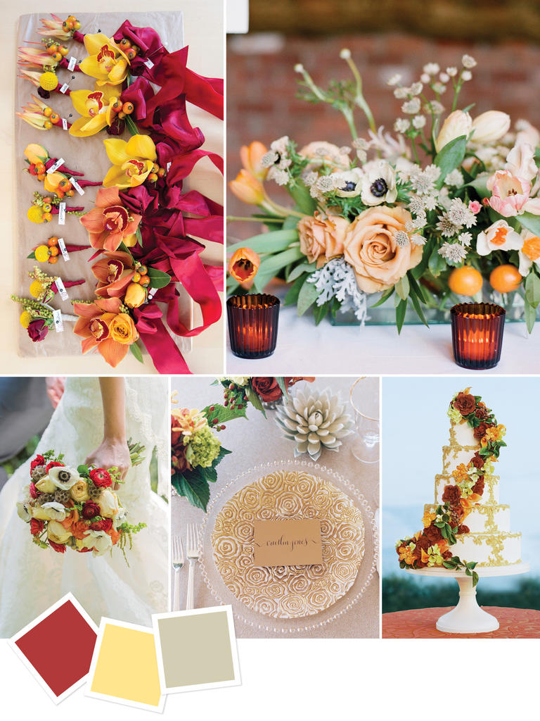
Seasonal Wedding designs 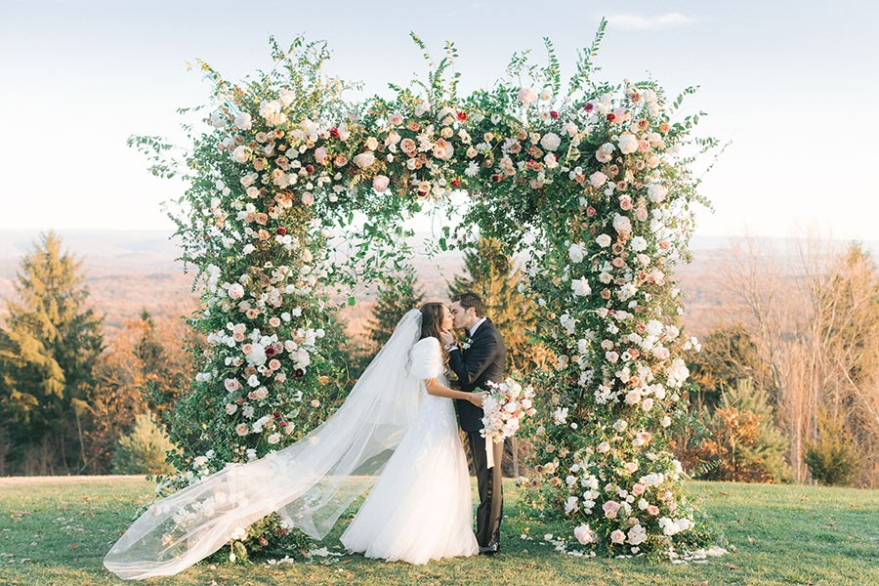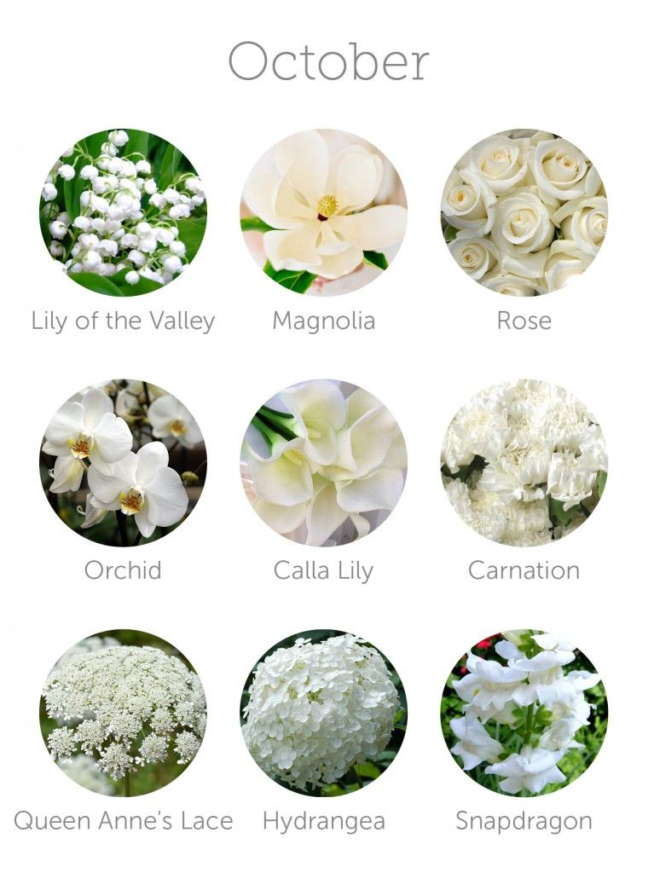 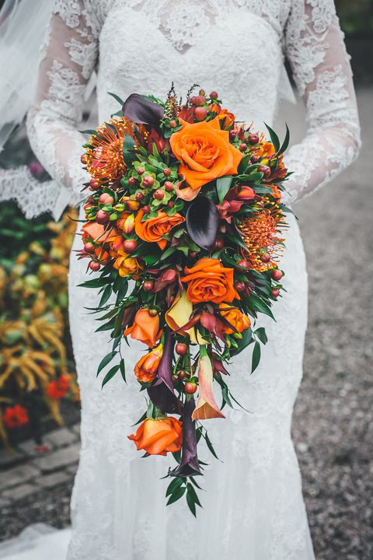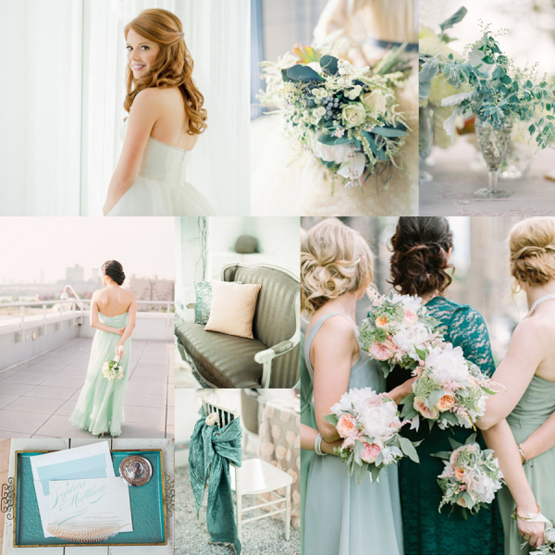

Additional Income

My additional income would be my venue and my store with everything an event planner would need. For Example:
  - Tables
  - Chairs
  - Tablecloths
  - Linens
  - Glue guns
  - Vases
  - Flowers
  - Glitter
  - Chair covers
10.Baby shower chairs
11.Pins and other things needed.

Relationship Expert information

Couples counseling NYC-Rachel Sussman, LCSW
85 5th Ave 9th floor, New York, NY 10003
Open Mon-Friday 12AM-7PM, 11AM-7PM

Psychology Today.com
Why Relationships matter? “Love is one of the most profound emotions known to human beings. The need for human connection appears to be natural but the ability to form healthy. Loving relationships is learned”.
Talk Space.com Relationship insecurities
  - Is it me? 2. Is it my partner is he/she doing something to make me feel insecure? 3. Is it the situation I find myself, Am I in a place with my partner that is naturally uncomfortable or settle?

Shower Party Theme & Ideas
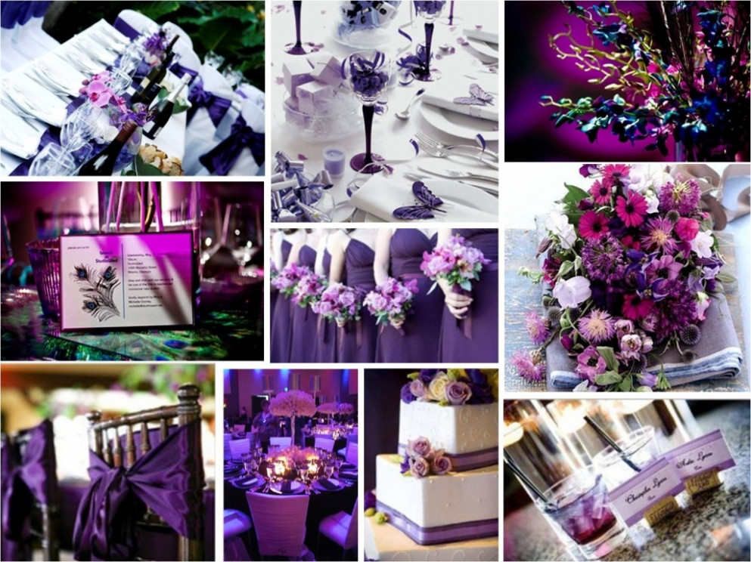
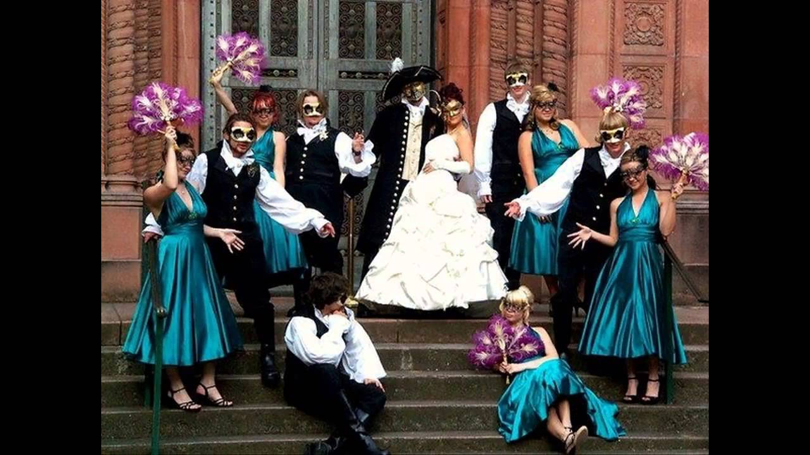

Alice in Wonderland
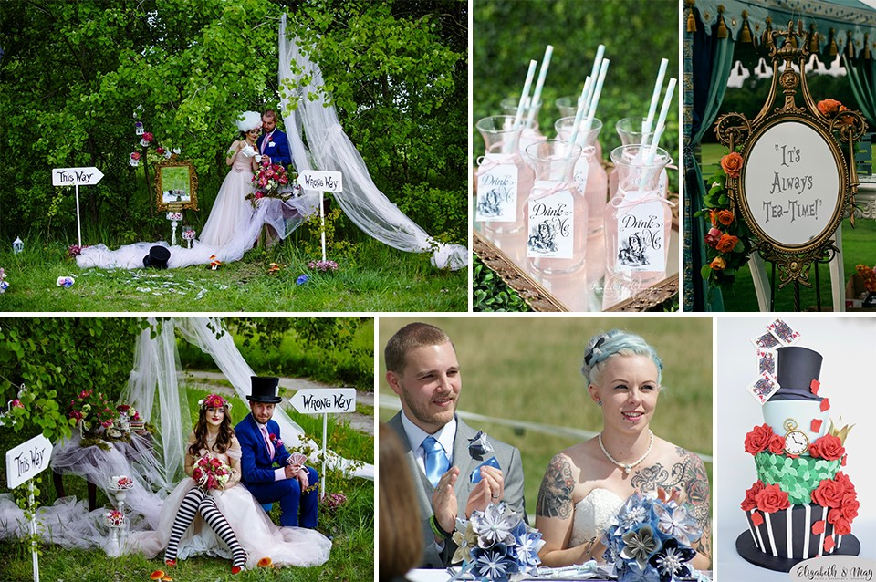

Fire and ice theme Wedding party
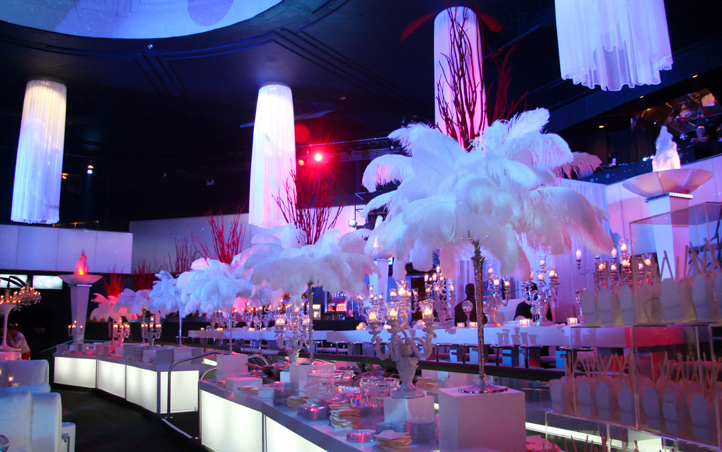
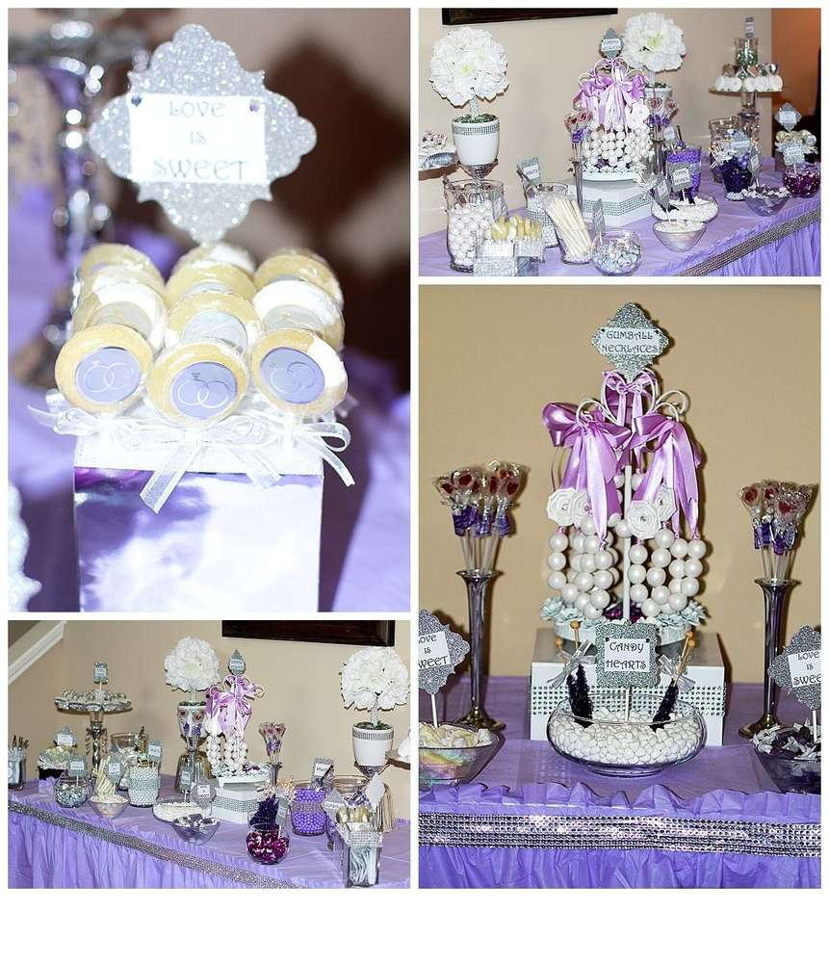
Diamonds and pearl shower theme

