In the Know
May 2019

Meet New Board Members Serving 2019-2022
Gina Pietrocola
Gina Pietrocola is President of D.J.A. Imports, Bronx, New York, a leading industry partner of ornamental steel and gate hardware. A long time community volunteer, Gina previously served 6 years on the NOMMA Board. As an educator, Gina brings a different perspective to her role as an Industry Partner Director. For the last 20 years, she has been an active member of numerous NOMMA committees and work groups. She is passionate about a board being effective. It’s members bring their experiences from the business and professional sectors, as well as life lessons. Volunteering can be extremely rewarding and educational.

Kendall Shrock
Kendall has been in the metal industry since 2001. His experience started with installing railings for his father and now to project management ranging from residential to large commercial jobs. Roger Good, former president of NOMMA, has been a valuable mentor. Shrock Fabrication has been a NOMMA member since 2013, and Kendall has been an active member of the NOMMA Network (ListServ) as well as attending METALFAB as regularly. His passion is technical problem-solving and innovation. He hopes to continue to build value to the NOMMA membership as he serves on the board for the next three years. He comes from a farming family, and continues to actively operate organic crop farms in Northern Illinois. He’s been a volunteer firefighter for 15 years and served on various nonprofit boards and committees.

Peter Zadrozinski
Peter is the Owner/President of both Classic Metal Craft (CMC) and JB Fence & Fabrication in St. Louis, MO. Peter purchased CMC 12 years ago and JB Fence 3 years ago. Both were purchased from the original owners. Peter has a bachelor’s degree in Manufacturing Engineering and an Associates degree in Industrial Technology. Peter grew up in and around construction. Peter is relatively new to the Ornamental Iron industry as compared to other leaders and hopes to bring a different perspective than those who started out as fabricators. Prior to buying his business’s he served as General Manager of a 60-person operation and Vice President of Operations with more than 200 employees in the printing industry. CMC has been a member of NOMMA since 2007.

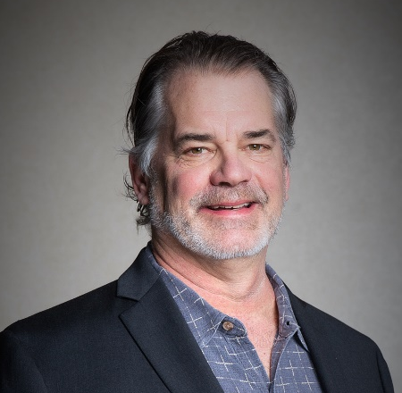
Introducing New Members of the Board Executive Committee
Jonathan Falk, NOMMA Vice President/Treasurer
Jonathan has been on the NOMMA board since 2017, and joined the Executive Committee in 2019. He is a partner in Living Design Studios, Erie, Colorado, and serves as the Director of Operations. He has participated in most aspects of the construction industry since high school; from digging foundations to installing high end ornamental metal work, to management and ownership. All of this direct experience has helped him grow their company. He is passionate about educating people about the great gifts of NOMMA membership and the educating of future fabricators.

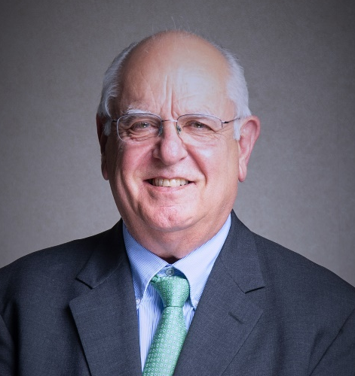
Dave Filippi, Senior Industry Partner Director
As a NOMMA member since 1975, Dave previously has served on NOMMA’s board and was President in the mid 1990’s. While operating Colonial Iron Works, Dave founded FabCAD which introduced the ornamental metal industry to computer aided design. During his time in NOMMA, Dave has been recognized for service to the industry as the recipient of the Julius Blum Award, the Frank Kozi k Award and the Cliff Brown Award. Currently Dave is serving as the Senior Industry Partner member of the board.

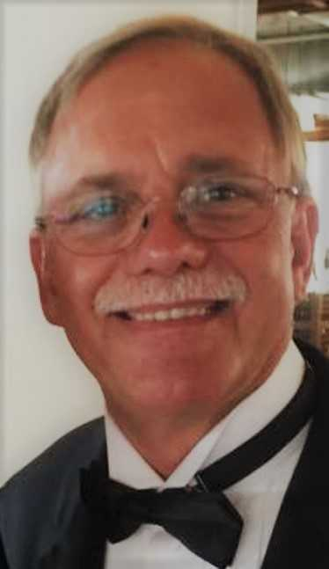
In Memory – Mittler Bros. Machine & Tool Co-Owner
Michael C. Mittler, born October 6, 1951, lost his battle with cancer May 10, 2019. Michael is survived by his wife Beverly J. Mittler (Tillman), six siblings and numerous nieces and nephews and great-nieces and great-nephews. Mike was a co-owner of Mittler Brothers Machine & Tool in Wright City, MO. Mike’s greatest passion was racing, he owned MB Motorsports who ran the #63 NASCAR truck for 23 years. He was National Chairman of National Tool and Machine Association in 2006 and remained an active member. Mittler Bros. has been a NOMMA member since 1991 and an active supporter of METALfab conferences. He will be missed by those who knew and loved him. The NOMMA family sends our thoughts to the family and his company family.
In lieu of flowers, donations may be made payable to: St. Vincent DePaul Society at Immaculate Heart of Mary, St. Louis Zoo, Humane Society of choice, or National Tooling and Machine Association, in care of Pitman Funeral Home, P. O. Box 248, Wentzville, MO 63385

NOMMA News
Chapter Meeting
Upper Midwest Chapter Meeting
Martinsville, IN // Saturday, June 22
Info: www.nomma.org/XXXXXX (meda is posting on the web)

NEF PRO – AUG 2019
Save the Date! August 9-10 2019, near Denver, CO Living Design Studio.
Curved Railings: From Field to Fabrication is the title of the course. Learn all the ins and outs of curved rails from experts.

